Machine-learning technology powers many aspects of modern society: from web
searches to content filtering on social networks to recommendations on e-
commerce websites, and it is increasingly present in consumer products such as
cameras and smartphones. Machine-learning systems are used to identify objects
in images, transcribe speech into text, match news items, posts or products with
users’ interests, and select relevant results of search.
Increasingly, these applications make use of a class of techniques called deep learning.
Conventional machine-learning techniques were limited in their ability to process
natural data in their raw form. For decades, constructing a pattern-recognition or
machine-learning system required careful engineering and considerable domain
expertise to design a feature extractor that transformed the raw data (such as the
pixel values of an image) into a suitable internal representation or feature vector
from which the learning subsystem, often a classifier, could detect or classify
patterns in the input.
Representation learning is a set of methods that allows a machine to be fed with
raw data and to automatically discover the representations needed for detection or
classification. Deep-learning methods are representation-learning methods with
multiple levels of representation, obtained by composing simple but non-linear


modules that each transform the representation at one level (starting with the raw
input) into a representation at a higher, slightly more abstract level.
With the composition of enough such transformations, very complex functions
can be learned. For classification tasks, higher layers of representation amplify
aspects of the input that are important for discrimination and suppress irrelevant
variations. An image, for example, comes in the form of an array of pixel values,
and the learned features in the first layer of representation typically represent the
presence or absence of edges at particular orientations and locations in the image.
The second layer typically detects motifs by spotting particular arrangements of
edges, regardless of small variations in the edge positions. The third layer may
assemble motifs into larger combinations that correspond to parts of familiar
objects, and subsequent layers would detect objects as combinations of these parts.
The key aspect of deep learning is that these layers of features are not designed by
human engineers: they are learned from data using a general-purpose learning
procedure.
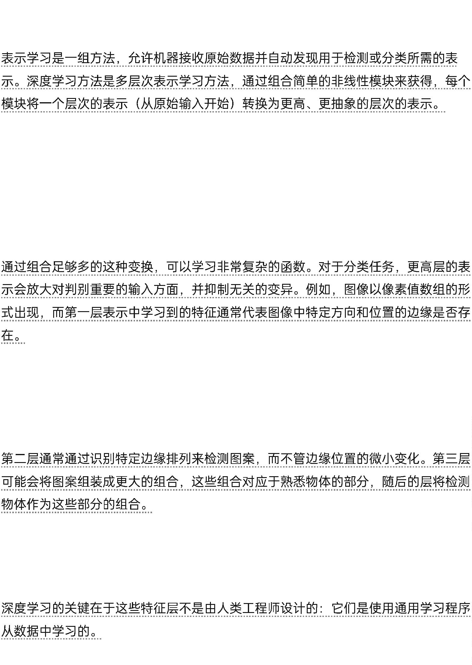

Deep learning is making major advances in solving problems that have resisted the
best attempts of the artificial intelligence community for many years. It has turned
out to be very good at discovering intricate structures in high-dimensional data
and is therefore applicable to many domains of science, business and government.
In addition to beating records in image recognition1–4 and speech recognition5–7,
it has beaten other machine-learning techniques at predicting the activity of
potential drug molecules8, analysing particle accelerator data9,10, reconstructing
brain circuits11, and predicting the effects of mutations in non-coding DNA on
gene expression and disease12,13.
1-4
5-7
8
9,10
11
DNA
12,13
Perhaps more surprisingly, deep learning has produced extremely promising
results for various tasks in natural language understanding14, particularly topic
classification, sentiment analysis, question answering15 and language
translation16,17.
14
15
16,17
We think that deep learning will have many more successes in the near future
because it requires very little engineering by hand, so it can easily take advantage of
increases in the amount of available computation and data. New learning
algorithms and architectures that are currently being developed for deep neural
networks will only accelerate this progress.
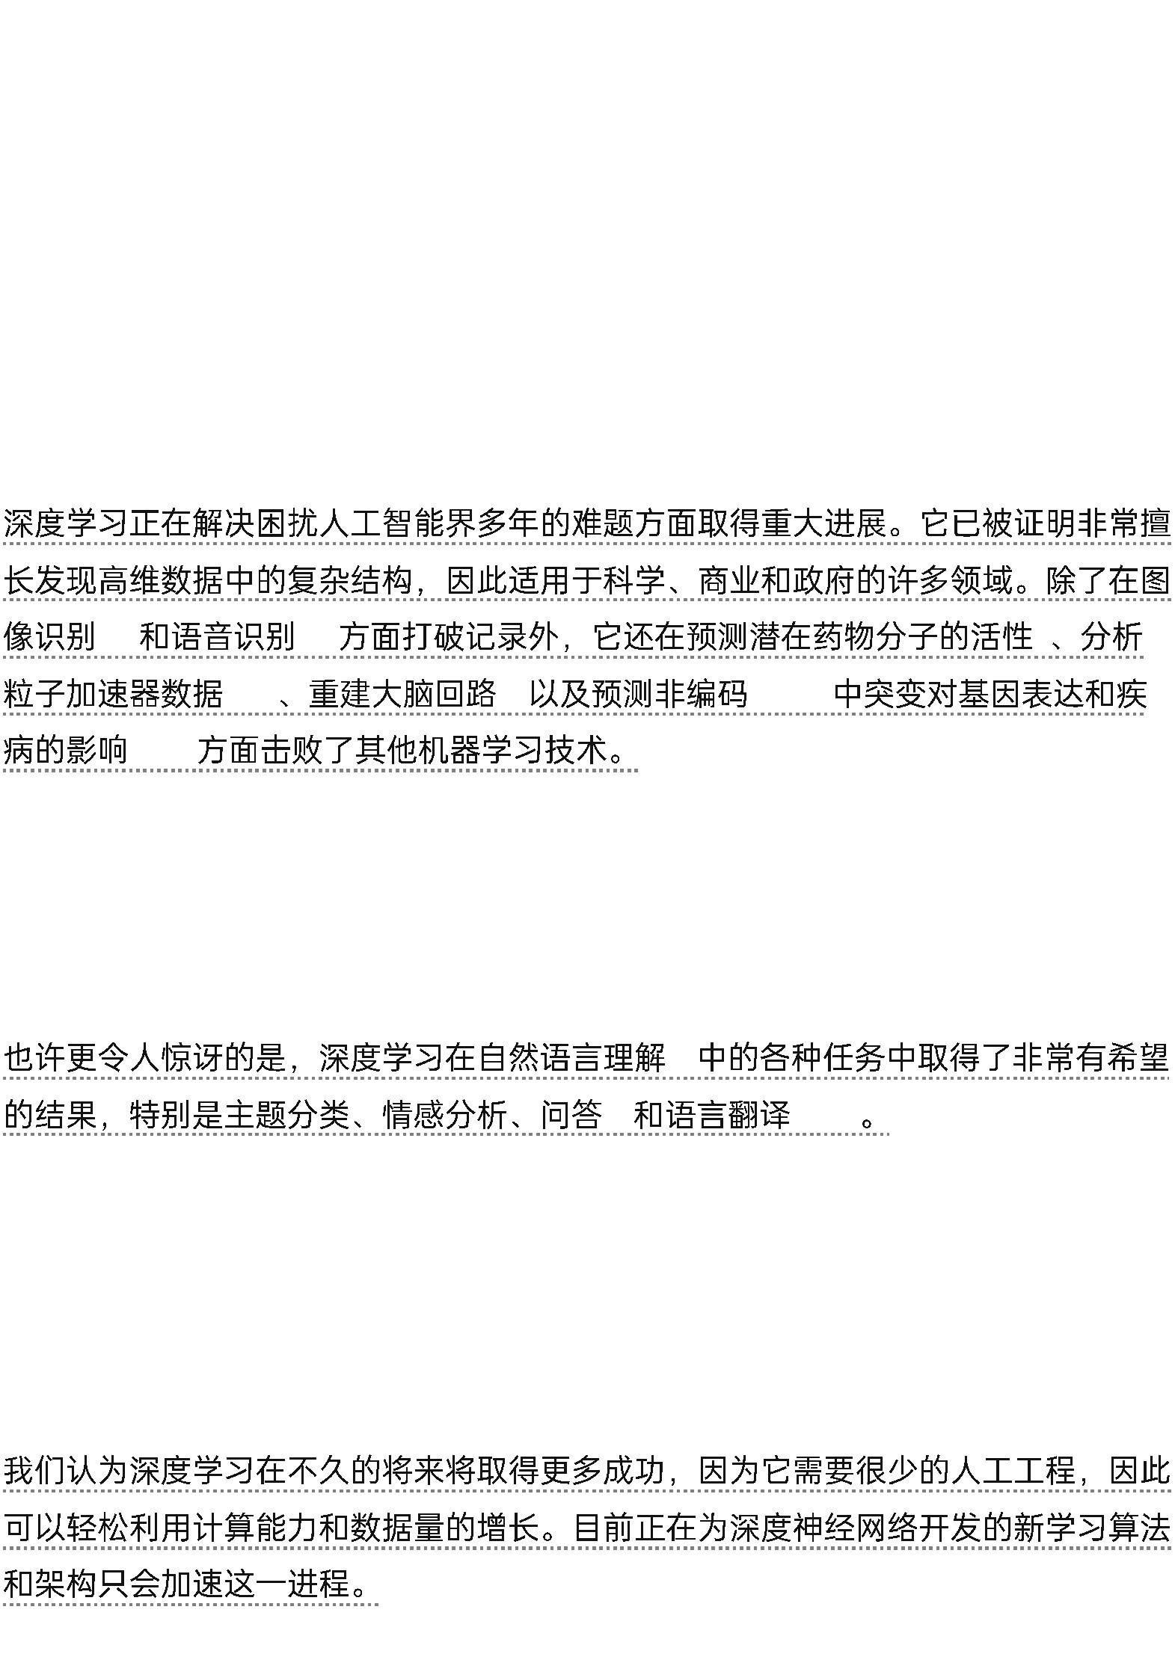

Supervised learning
The most common form of machine learning, deep or not, is supervised learning.
Imagine that we want to build a system that can classify images as containing, say,
a house, a car, a person or a pet. We first collect a large data set of images of
houses, cars, people and pets, each labelled with its category.
During training, the machine is shown an image and produces an output in the
form of a vector of scores, one for each category. We want the desired category to
have the highest score of all categories, but this is unlikely to happen before
training.
We compute an objective function that measures the error (or distance) between
the output scores and the desired pattern of scores. The machine then modifies its
internal adjustable parameters to reduce this error. These adjustable parameters,
often called weights, are real numbers that can be seen as ‘knobs’ that define the
input–output function of the machine.
-
“
”
In a typical deep-learning system, there may be hundreds of millions of these
adjustable weights, and hundreds of millions of labelled examples with which to
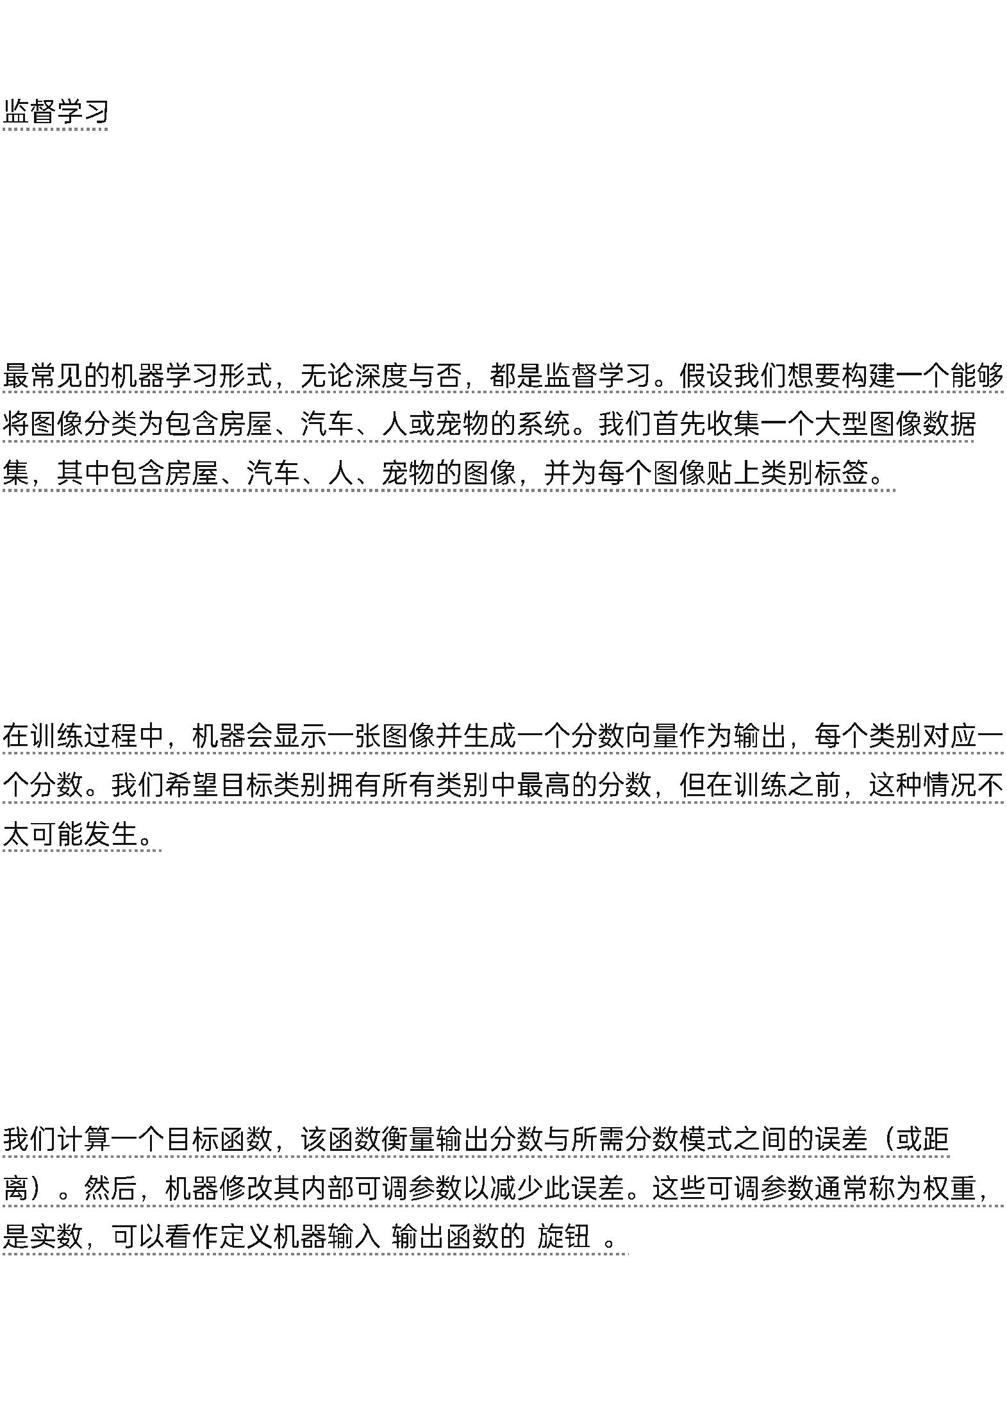

train the machine.
To properly adjust the weight vector, the learning algorithm computes a gradient
vector that, for each weight, indicates by what amount the error would increase or
decrease if the weight were increased by a tiny amount. The weight vector is then
adjusted in the opposite direction to the gradient vector.
The objective function, averaged over all the training examples, can
Deep learning allows computational models that are composed of
multiple processing layers to learn representations of data with multiple
levels of abstraction. These methods have dramatically improved the
state-of-the-art in speech recognition, visual object recognition, object
detection and many other domains such as drug discovery and
genomics.
Deep learning discovers intricate structure in large data sets by using
the backpropagation algorithm to indicate how a machine should
change its internal parameters that are used to compute the
representation in each layer from the representation in the previous
layer.


Deep convolutional nets have brought about breakthroughs in
processing images, video, speech and audio, whereas recurrent nets
have shone light on sequential data such as text and speech.
Deep learning


Yann LeCun1,2, Yoshua Bengio3 & Geoffrey Hinton4,5 be seen as a kind of
hilly landscape in the high-dimensional space of weight values. The negative
gradient vector indicates the direction of steepest descent in this landscape, taking
it closer to a minimum, where the output error is low on average.
Yann LeCun1,2, Yoshua Bengio3 & Geoffrey Hinton4,5
In practice, most practitioners use a procedure called stochastic gradient descent
(SGD). This consists of showing the input vector for a few examples, computing
the outputs and the errors, computing the average gradient for those examples, and
adjusting the weights accordingly.
(SGD)
The process is repeated for many small sets of examples from the training set until
the average of the objective function stops decreasing. It is called stochastic because
each small set of examples gives a noisy estimate of the average gradient over all
examples.
This simple procedure usually finds a good set of weights surprisingly quickly
when compared with far more elaborate optimization techniques18. After training,
the performance of the system is measured on a different set of examples called a
test set. This serves to test the generalization ability of the machine — its ability to
produce sensible answers on new inputs that it has never seen during training.
[
NT]18[NT]
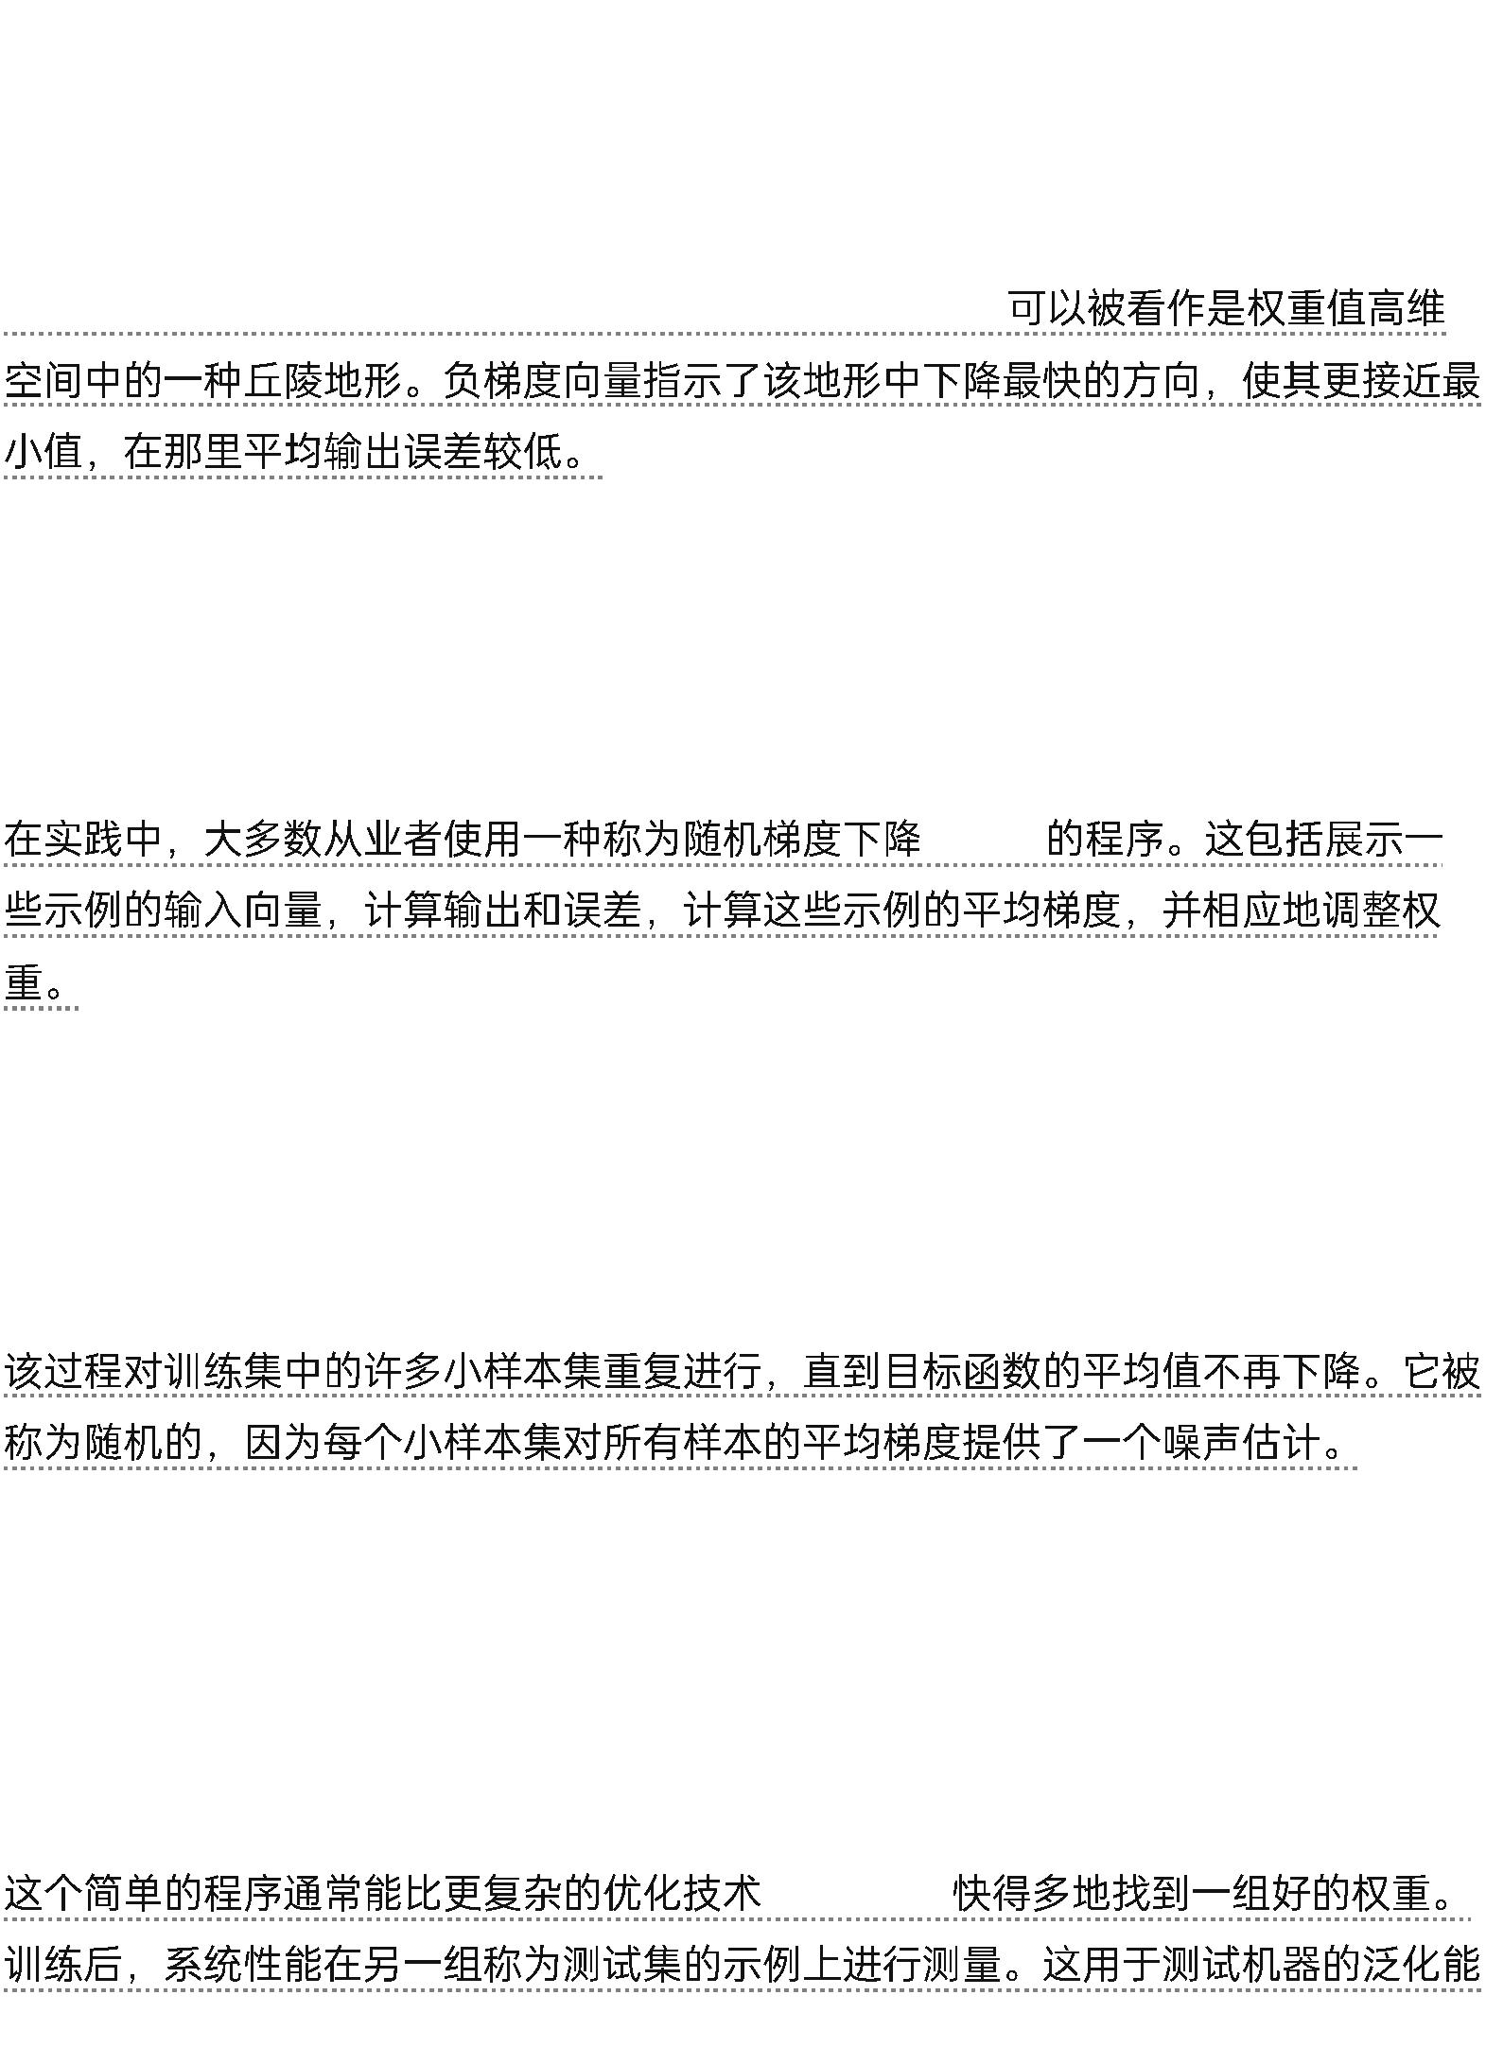

——
Many of the current practical applications of machine learning use linear classifiers
on top of hand-engineered features. A two-class linear classifier computes a
weighted sum of the feature vector components. If the weighted sum is above a
threshold, the input is classified as belonging to a particular category.
Since the 1960s we have known that linear classifiers can only carve their input
space into very simple regions, namely half-spaces separated by a hyperplane19.
But problems such as image and speech recognition require the input–output
function to be insensitive to irrelevant variations of the input, such as variations in
position, orientation or illumination of an object, or variations in the pitch or
accent of speech, while being very sensitive to particular minute variations (for
example, the difference between a white wolf and a breed of wolf-like white dog
called a Samoyed).
20
60
[NT]1[NT]
-
At the pixel level, images of two Samoyeds in different poses and in different
environments may be very different from each other, whereas two images of a
Samoyed and a wolf in the same position and on similar backgrounds may be very
similar to each other.
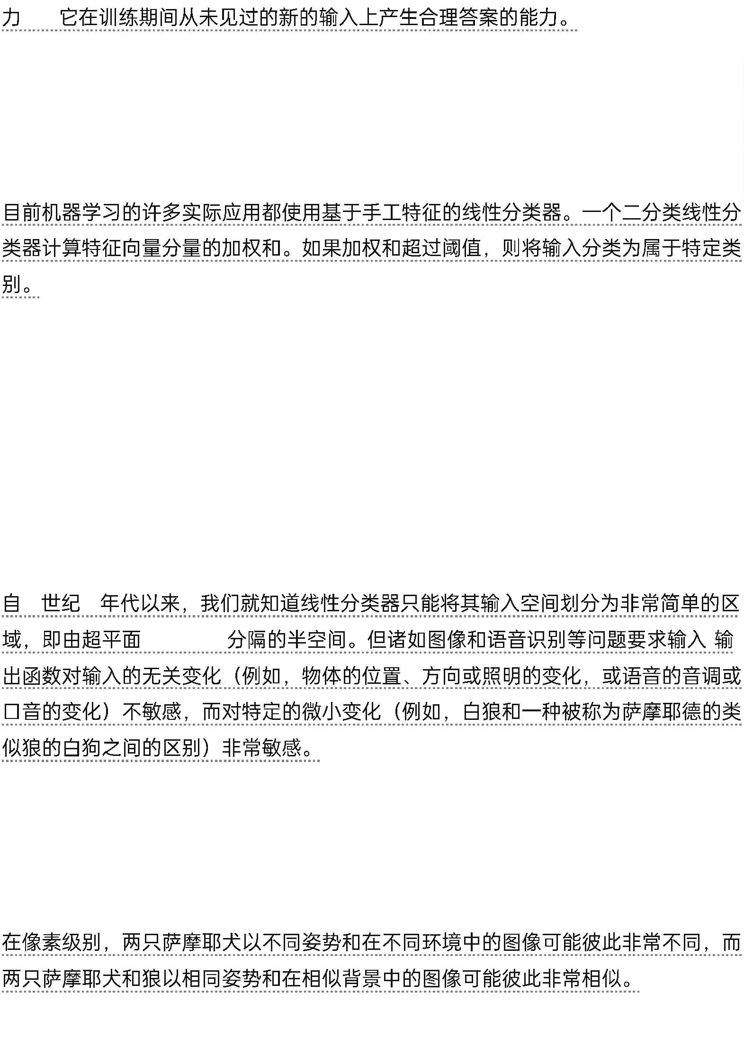

A linear classifier, or any other ‘shallow’ classifier operating on
Figure 1 | Multilayer neural networks and backpropagation. a, A multilayer
neural network (shown by the connected dots) can distort the input space to make
the classes of data (examples of which are on the red and blue lines) linearly
separable.
1
|
a
Note how a regular grid (shown on the left) in input space is also transformed
(shown in the middle panel) by hidden units. This is an illustrative example with
only two input units, two hidden units and one output unit, but the networks used
for object recognition or natural language processing contain tens or hundreds of
thousands of units.
Reproduced with permission from C. Olah (http://colah.github.io/). b, The chain
rule of derivatives tells us how two small effects (that of a small change of x on y ,
and that of y on z) are composed. A small change Δx in x gets transformed first
into a small change Δy in y by getting multiplied by ∂y/∂x (that is, the definition of
partial derivative).
C. Olah
(http://colah.github.io/). b).
x
y
y
z
x
Δx
∂y/∂x
y
Δy
Similarly, the change Δy creates a change Δz in z . Substituting one equation into
the other gives the chain rule of derivatives — how Δx gets turned into Δz through
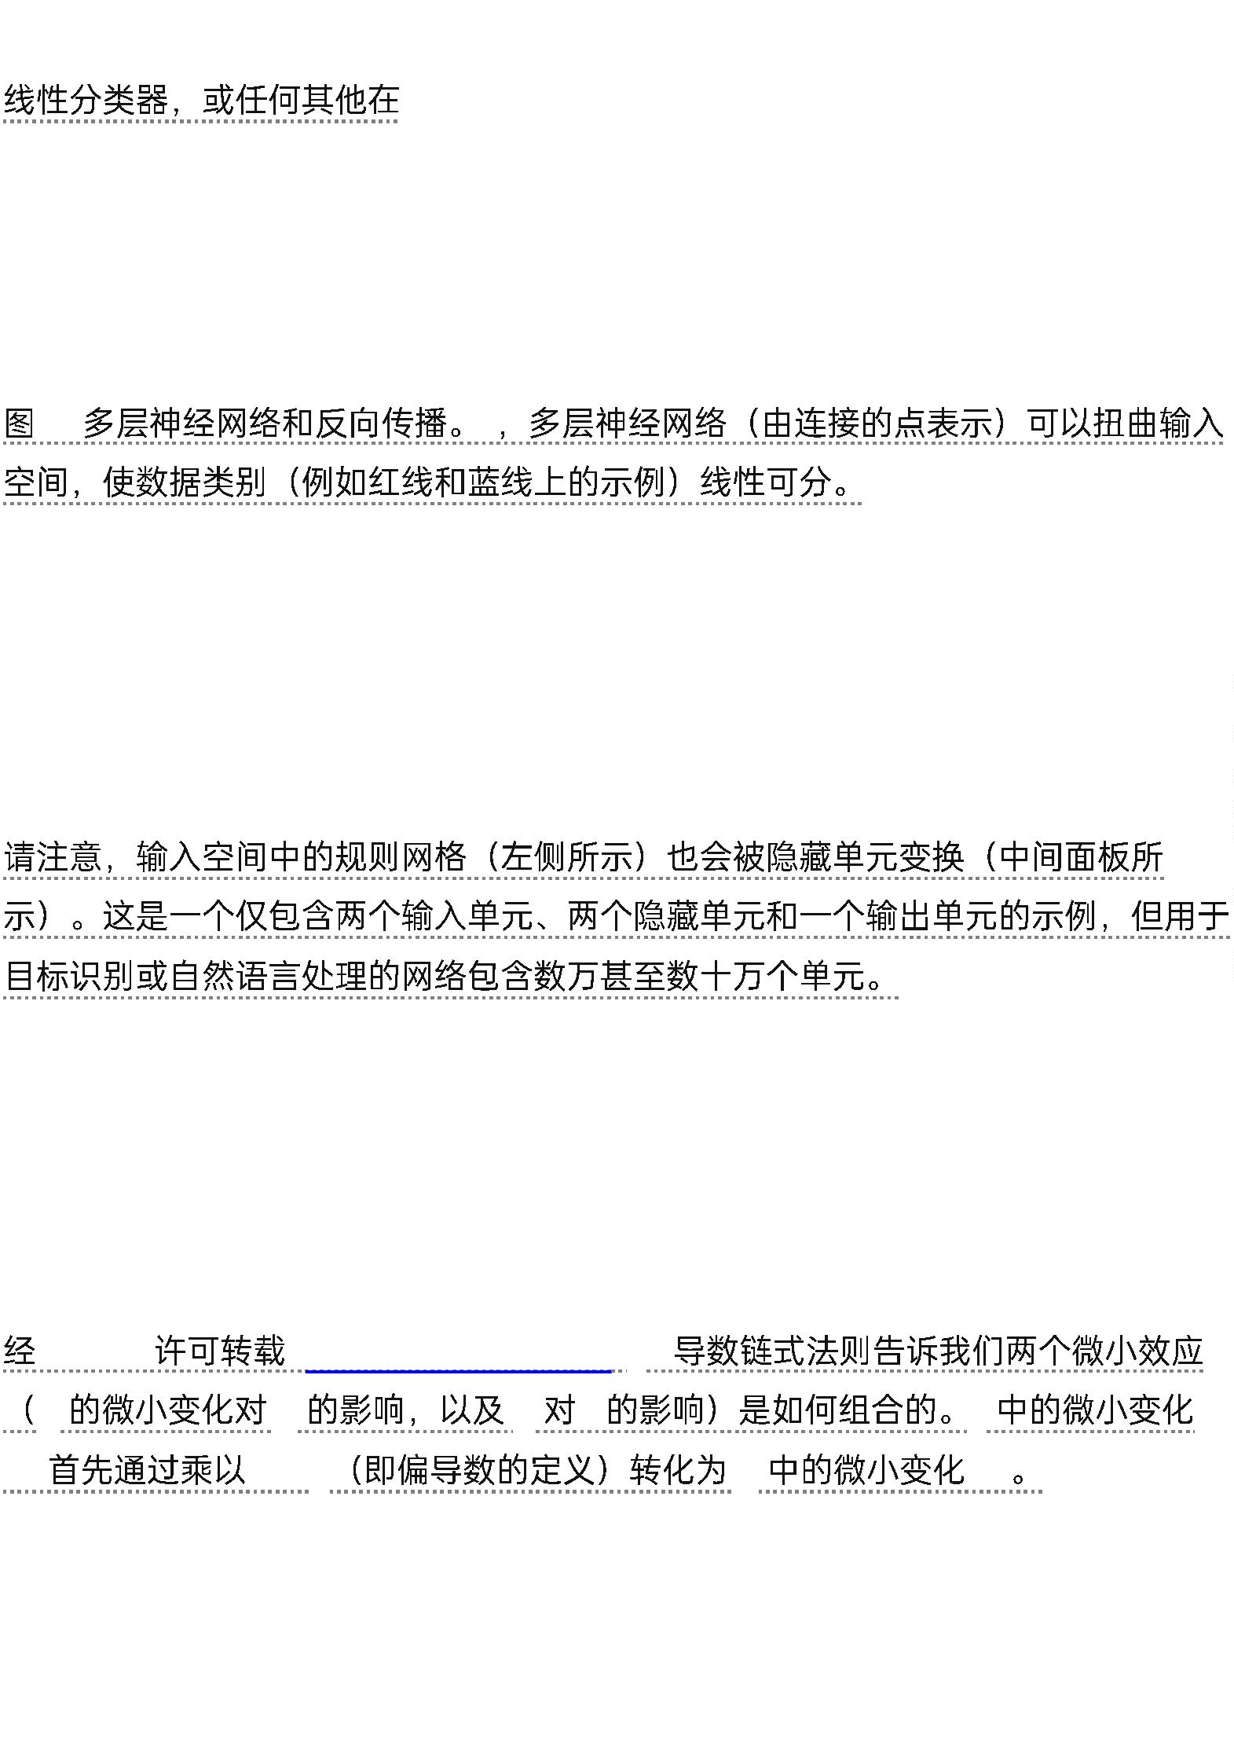

multiplication by the product of ∂y/∂x and ∂z/∂x. It also works when x , y and z are
vectors (and the derivatives are Jacobian matrices).
Δy
z
Δz
——
∂y/∂x ∂z/∂x
Δx
Δz
x y
z
c , The equations used for computing the forward pass in a neural net with two
hidden layers and one output layer, each constituting a module through which one
can backpropagate gradients. At each layer, we first compute the total input z to
each unit, which is a weighted sum of the outputs of the units in the layer below.
Then a non-linear function f (.) is applied to z to get the output of the unit.
c ,
z
f (.)
z
For simplicity, we have omitted bias terms. The non-linear functions used in
neural networks include the rectified linear unit (ReLU) f (z) = max(0,z),
commonly used in recent years, as well as the more conventional sigmoids, such as
the hyberbolic tangent, f(z) = (exp(z) − exp(−z))/(exp(z) + exp(−z)) and logistic
function logistic, f(z) = 1/(1 + exp(−z)).
(ReLU) f (z) = max(0,z)
sigmoid
f
(z) = (exp(z) − exp(−z))/(exp(z) + exp(−z))
logistic f(z) = 1/(1 + exp(−z))
d , The equations used for computing the backward pass. At each hidden layer we
compute the error derivative with respect to the output of each unit, which is a
weighted sum of the error derivatives with respect to the total inputs to the units in
the layer above.
d ,
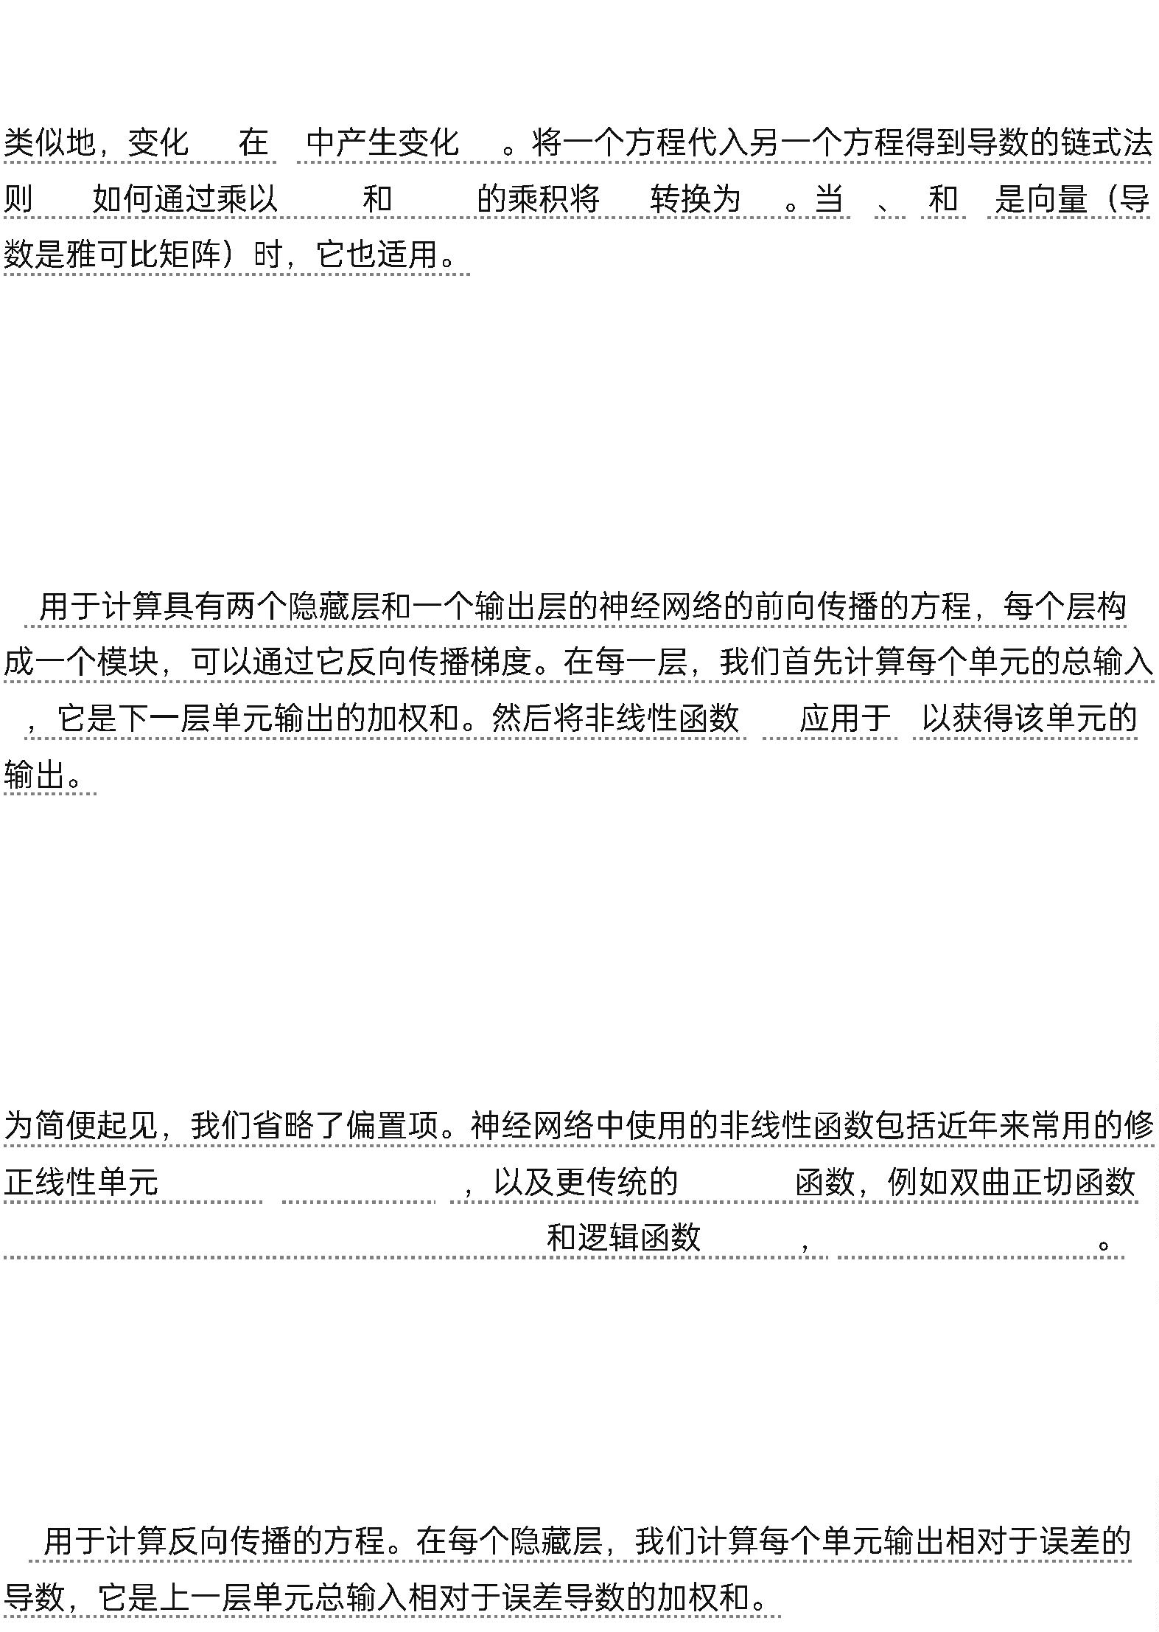

We then convert the error derivative with respect to the output into the error
derivative with respect to the input by multiplying it by the gradient of f (z). At the
output layer, the error derivative with respect to the output of a unit is computed
by differentiating the cost function.
然后，我们将误差关于输出的导数乘以f (z)的梯度，将其转换为误差关于输入的导数。在输出层，误差关于单元输出的导数通过对代价函数求导来计算。
This gives y − t if the cost function for unit l is 0.5(y − t ² , where t is the target
)
l
l
l
l
l
value. Once the ∂E/∂z is known, the error-derivative for the weight w on the
k
jk
connection from unit j in the layer below is just y ∂E/∂z .
j
k
这将得到y_{l} − t_{l，}如果单元l的成本函数为0.5(y_{l} − t_{l} )²，其中t_{l} 是目标值。一旦∂E/∂z_{k} 已知，则连接到下面层中单元j的权重w_{jk}的误差导数仅为y_{j} ∂E/∂z_{k} 。

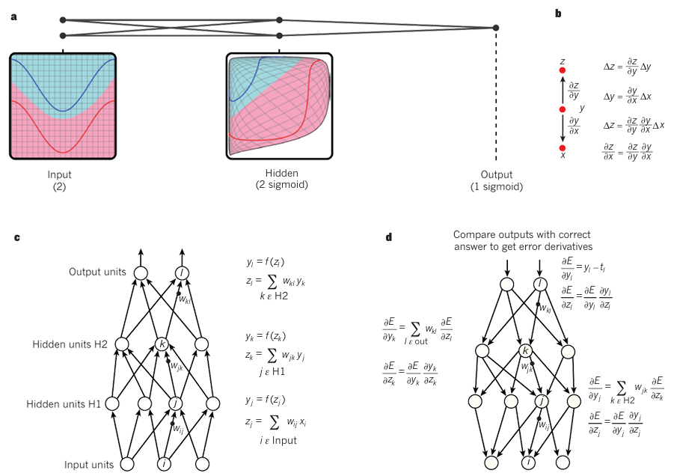

raw pixels could not possibly distinguish the latter two, while putting the former
two in the same category. This is why shallow classifiers require a good feature
extractor that solves the selectivity–invariance dilemma — one that produces
representations that are selective to the aspects of the image that are important for
discrimination, but that are invariant to irrelevant aspects such as the pose of the
animal.
-
——
To make classifiers more powerful, one can use generic non-linear features, as with
kernel methods20, but generic features such as those arising with the Gaussian
kernel do not allow the learner to generalize well far from the training examples21.
The conventional option is to hand design good feature extractors, which requires
a considerable amount of engineering skill and domain expertise.
20
21
But this can all be avoided if good features can be learned automatically using a
general-purpose learning procedure. This is the key advantage of deep learning.
A deep-learning architecture is a multilayer stack of simple modules, all (or most)
of which are subject to learning, and many of which compute non-linear input–
output mappings. Each module in the stack transforms its input to increase both
the selectivity and the invariance of the representation.


-
With multiple non-linear layers, say a depth of 5 to 20, a system can implement
extremely intricate functions of its inputs that are simultaneously sensitive to
minute details — distinguishing Samoyeds from white wolves — and insensitive to
large irrelevant variations such as the background, pose, lighting and surrounding
objects.
5
20
——
——
Backpropagation to train multilayer architectures
From the earliest days of pattern recognition22,23, the aim of researchers has been
to replace hand-engineered features with trainable multilayer networks, but despite
its simplicity, the solution was not widely understood until the mid 1980s. As it
turns out, multilayer architectures can be trained by simple stochastic gradient
descent.
22,23
1980
As long as the modules are relatively smooth functions of their inputs and of their
internal weights, one can compute gradients using the backpropagation procedure.
The idea that this could be done, and that it worked, was discovered independently
by several different groups during the 1970s and 1980s24–27.
1970
1980


24–27
The backpropagation procedure to compute the gradient of an objective function
with respect to the weights of a multilayer stack of modules is nothing more than a
practical application of the chain rule for derivatives. The key insight is that the
derivative (or gradient) of the objective with respect to the input of a module can
be computed by working backwards from the gradient with respect to the output
of that module (or the input of the subsequent module) (Fig. 1). The
backpropagation equation can be applied repeatedly to propagate gradients
through all modules, starting from the output at the top (where the network
produces its prediction) all the way to the bottom (where the external input is fed).
1
Once these gradients have been computed, it is straightforward to compute the
gradients with respect to the weights of each module.
Many applications of deep learning use feedforward neural network architectures
(Fig. 1), which learn to map a fixed-size input (for example, an image) to a fixed-
size output (for example, a probability for each of several categories). To go from
one layer to the next, a set of units compute a weighted sum of their inputs from
the previous layer and pass the result through a non-linear function.
1
At present, the most popular non-linear function is the rectified linear unit
(ReLU), which is simply the half-wave rectifier f (z) = max(z, 0). In past decades,
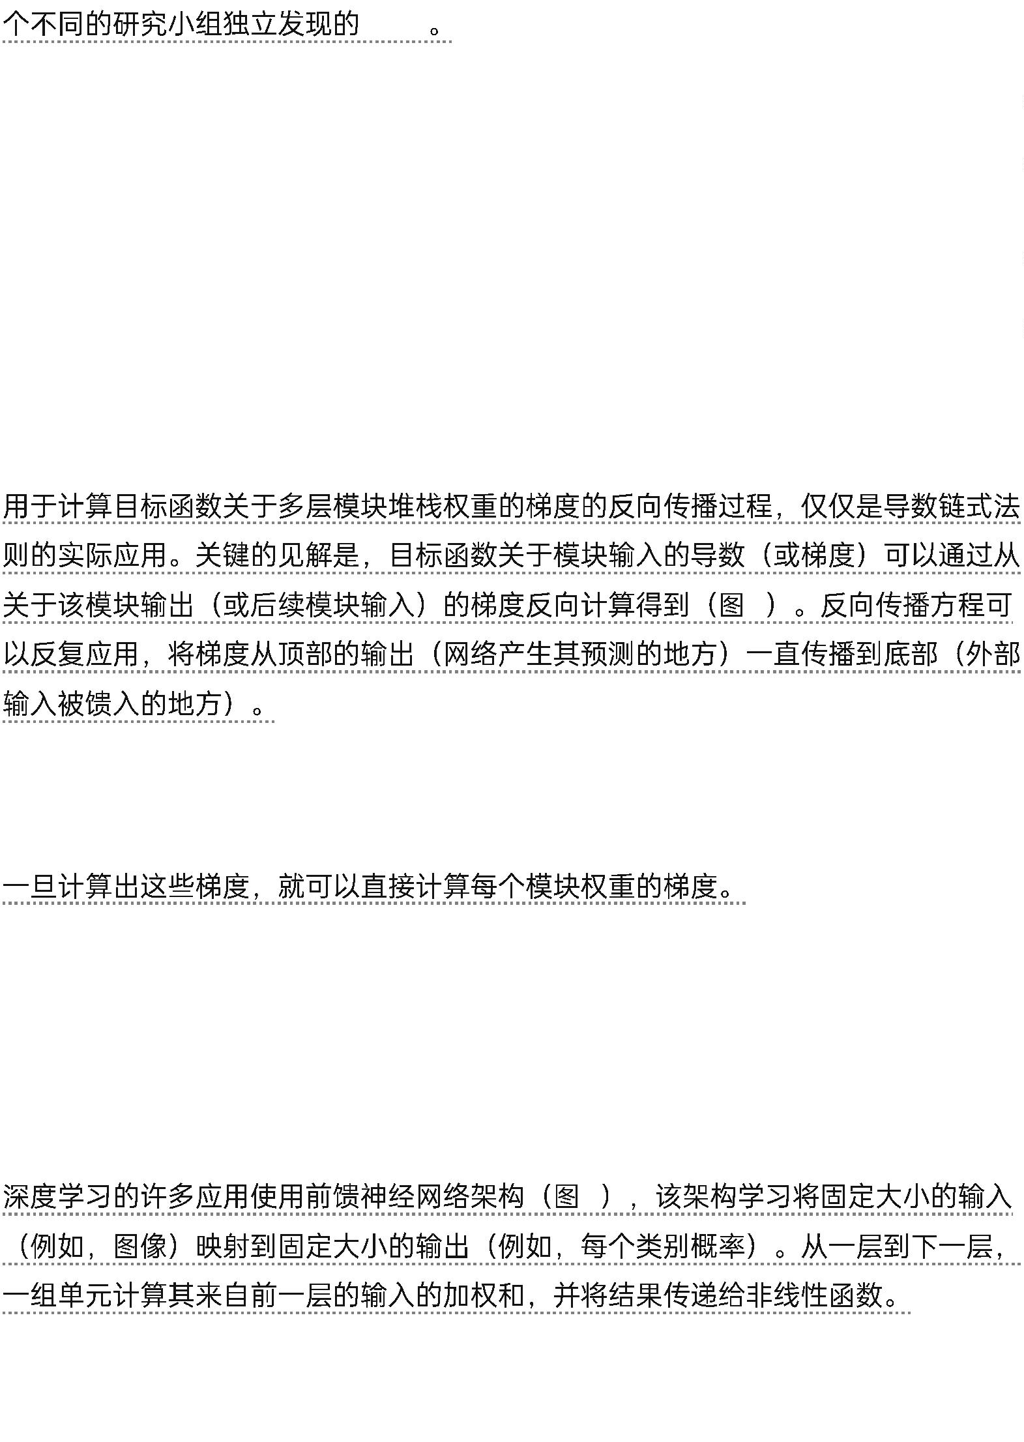

neural nets used smoother non-linearities, such as tanh(z) or 1/(1 + exp(−z)), but
the ReLU typically learns much faster in networks with many layers, allowing
training of a deep supervised network without unsupervised pre-training28.
(ReLU)
f (z) = max(z,
tanh(z) 1/(1 +
0)
exp(−z))
ReLU
28
Units that are not in the input or output layer are conventionally called hidden
units. The hidden layers can be seen as distorting the input in a non-linear way so
that categories become linearly separable by the last layer (Fig. 1).
1
In the late 1990s, neural nets and backpropagation were largely forsaken by the
machine-learning community and ignored by the computer-vision and speech-
recognition communities. It was widely thought that learning useful, multistage,
feature extractors with little prior knowledge was infeasible. In particular, it was
commonly thought that simple gradient descent would get trapped in poor local
minima — weight configurations for which no small change would reduce the
average error.
20
90
——
In practice, poor local minima are rarely a problem with large networks. Regardless
of the initial conditions, the system nearly always reaches solutions of very similar
quality. Recent theoretical and empirical results strongly suggest that local minima
are not a serious issue in general.
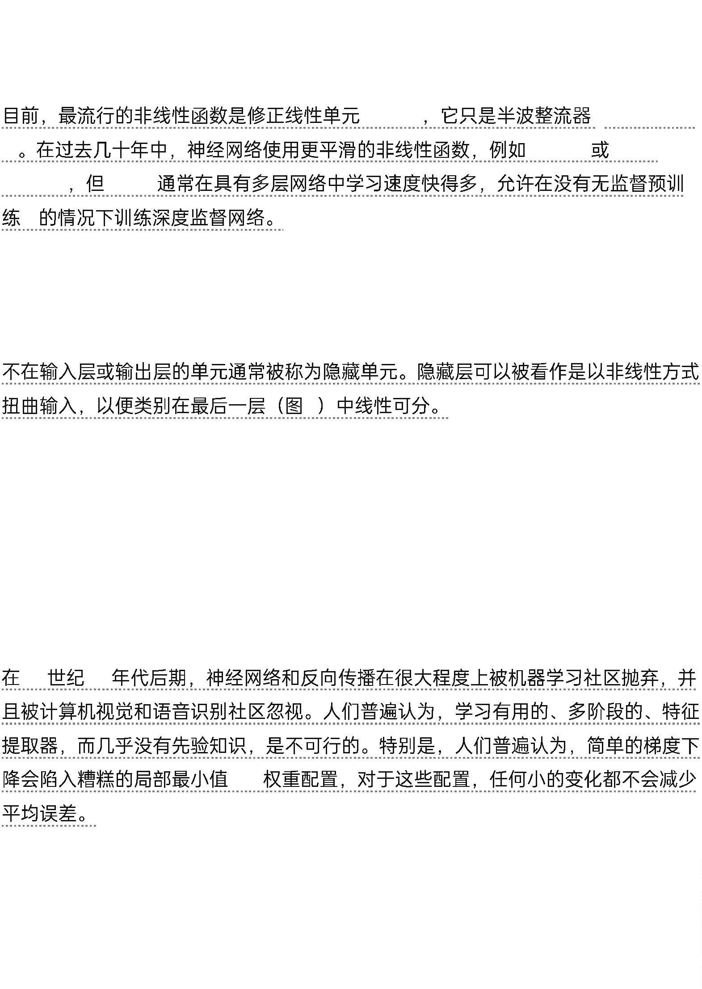

在实践中，对于大型网络而言，局部极小值很少是一个问题。无论初始跳价如何，系统几乎总是能够达到质量非常相似的解。最近的理论和实证结果强烈表明，举报极小值通常不是一个严重的问题。

Instead, the landscape is packed with a combinatorially large number of saddle
points where the gradient is zero, and the surface curves up in most dimensions
and curves down in the

相反，该景观充满了组合爆炸数量的鞍点，这些鞍点处的梯度为零，并且曲面在大多数维度上向上弯曲，而在

Figure 2 | Inside a convolutional network. The outputs (not the filters) of each
layer (horizontally) of a typical convolutional network architecture applied to the
image of a Samoyed dog (bottom left; and RGB (red, green, blue) inputs, bottom
right). Each rectangular image is a feature map corresponding to the output for
one of the learned features, detected at each of the image positions. Information
flows bottom up, with lower-level features acting as oriented edge detectors, and a
score is computed for each image class in output. ReLU, rectified linear unit.
图2 卷积网络内部。典型卷积网络架构应用于萨摩耶犬图像（左下图；以及RGB（红、绿、蓝）输入，右下角）的每一层（水平）的输出（不是滤波器）。每个矩形图像是一个特征图，对应于在每个图像位置检测到的一个学习特征的输出。信心自下而上流动，低级特征充当定向边缘检测器，并为每个图像类别在输出中计算得分。ReLU，修正线性单元。

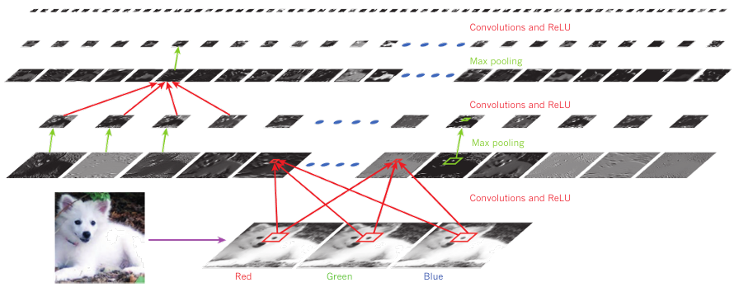

Samoyed (16); Papillon (5.7); Pomeranian (2.7); Arctic fox (1.0);
Eskimo dog (0.6); white wolf (0.4); Siberian husky (0.4) remainder29,30.
The analysis seems to show that saddle points with only a few downward curving
directions are present in very large numbers, but almost all of them have very
similar values of the objective function. Hence, it does not much matter which of
these saddle points the algorithm gets stuck at.
(16)
(5.7)
(0.4)
(2.7)
(1.0)
(0.6)
(0.4)
29,30
Interest in deep feedforward networks was revived around 2006 (refs 31–34) by a
group of researchers brought together by the Canadian Institute for Advanced
Research (CIFAR). The researchers introduced unsupervised learning procedures
that could create layers of feature detectors without requiring labelled data.
(CIFAR)
31-34)
2006
(
The objective in learning each layer of feature detectors was to be able to
reconstruct or model the activities of feature detectors (or raw inputs) in the layer
below. By ‘pre-training’ several layers of progressively more complex feature
detectors using this reconstruction objective, the weights of a deep network could
be initialized to sensible values.
“
”
A final layer of output units could then be added to the top of the network and the
whole deep system could be fine-tuned using standard backpropagation33–35.


This worked remarkably well for recognizing handwritten digits or for detecting
pedestrians, especially when the amount of labelled data was very limited36.
3
3–35
36
The first major application of this pre-training approach was in speech
recognition, and it was made possible by the advent of fast graphics processing
units (GPUs) that were convenient to program37 and allowed researchers to train
networks 10 or 20 times faster.
(GPU)
GPU
37
10
20
In 2009, the approach was used to map short temporal windows of coefficients
extracted from a sound wave to a set of probabilities for the various fragments of
speech that might be represented by the frame in the centre of the window.
2009
It achieved record-breaking results on a standard speech recognition benchmark
that used a small vocabulary38 and was quickly developed to give record-breaking
results on a large vocabulary task39. By 2012, versions of the deep net from 2009
were being developed by many of the major speech groups6 and were already
being deployed in Android phones.
[
NT]38[NT]
[NT]39[NT]
2012
[NT]6[NT]
2009
Android
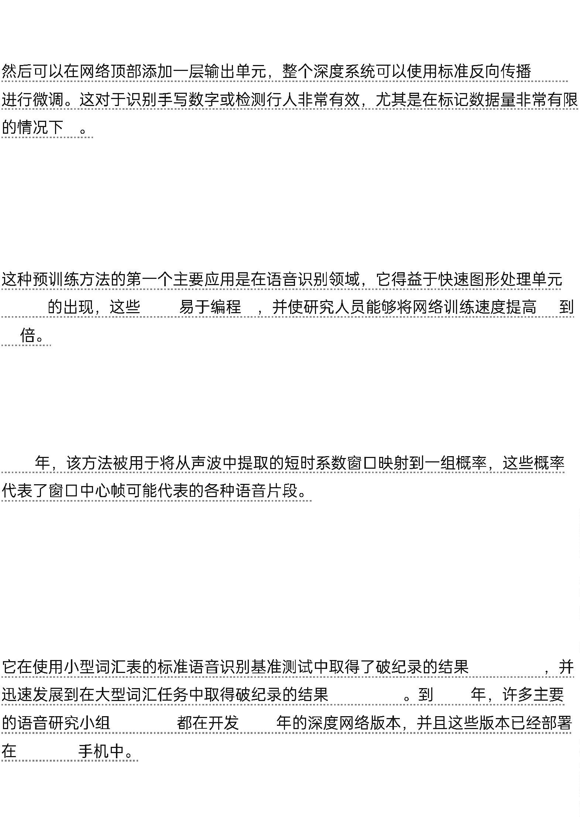

For smaller data sets, unsupervised pre-training helps to prevent overfitting40,
leading to significantly better generalization when the number of labelled examples
is small, or in a transfer setting where we have lots of examples for some ‘source’
tasks but very few for some ‘target’ tasks.
40
“
”
“
”
Once deep learning had been rehabilitated, it turned out that the pre-training stage
was only needed for small data sets.
There was, however, one particular type of deep, feedforward network that was
much easier to train and generalized much better than networks with full
connectivity between adjacent layers. This was the convolutional neural network
(ConvNet)41,42. It achieved many practical successes during the period when
neural networks were out of favour and it has recently been widely adopted by the
computervision community.
(ConvNet)41,42
Convolutional neural networks
ConvNets are designed to process data that come in the form of multiple arrays,
for example a colour image composed of three 2D arrays containing pixel
intensities in the three colour channels. Many data modalities are in the form of
multiple arrays: 1D for signals and sequences, including language; 2D for images or
audio spectrograms; and 3D for video or volumetric images.


There are four key ideas behind ConvNets that take advantage of the properties of
natural signals: local connections, shared weights, pooling and the use of many
layers.
(ConvNets)
The architecture of a typical ConvNet (Fig. 2) is structured as a series of stages. The
first few stages are composed of two types of layers: convolutional layers and
pooling layers. Units in a convolutional layer are organized in feature maps, within
which each unit is connected to local patches in the feature maps of the previous
layer through a set of weights called a filter bank.
2
The result of this local weighted sum is then passed through a non-linearity such as
a ReLU. All units in a feature map share the same filter bank. Different feature
maps in a layer use different filter banks. The reason for this architecture is
twofold. First, in array data such as images, local groups of values are often highly
correlated, forming distinctive local motifs that are easily detected. Second, the
local statistics of images and other signals are invariant to location. In other words,
if a motif can appear in one part of the image, it could appear anywhere, hence the
idea of units at different locations sharing the same weights and detecting the same
pattern in different parts of the array.
ReLU


Mathematically, the filtering operation performed by a feature map is a discrete
convolution, hence the name.
Although the role of the convolutional layer is to detect local conjunctions of
features from the previous layer, the role of the pooling layer is to merge
semantically similar features into one. Because the relative positions of the features
forming a motif can vary somewhat, reliably detecting the motif can be done by
coarse-graining the position of each feature.
A typical pooling unit computes the maximum of a local patch of units in one
feature map (or in a few feature maps). Neighbouring pooling units take input
from patches that are shifted by more than one row or column, thereby reducing
the dimension of the representation and creating an invariance to small shifts and
distortions.
Two or three stages of convolution, non-linearity and pooling are stacked, followed
by more convolutional and fully-connected layers. Backpropagating gradients
through a ConvNet is as simple as through a regular deep network, allowing all the
weights in all the filter banks to be trained.
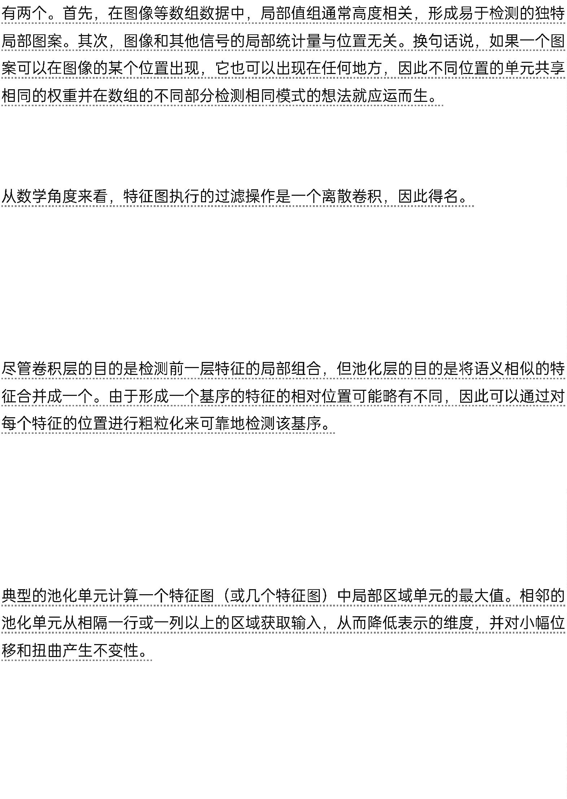

Deep neural networks exploit the property that many natural signals are
compositional hierarchies, in which higher-level features are obtained by
composing lower-level ones. In images, local combinations of edges form motifs,
motifs assemble into parts, and parts form objects. Similar hierarchies exist in
speech and text from sounds to phones, phonemes, syllables, words and sentences.
The pooling allows representations to vary very little when elements in the
previous layer vary in position and appearance.
The convolutional and pooling layers in ConvNets are directly inspired by the
classic notions of simple cells and complex cells in visual neuroscience43, and the
overall architecture is reminiscent of the LGN–V1–V2–V4–IT hierarchy in the
visual cortex ventral pathway44. When ConvNet models and monkeys are shown
the same picture, the activations of high-level units in the ConvNet explains half of
the variance of random sets of 160 neurons in the monkey’s inferotemporal
cortex45.
43
LGN-V1-V2-V4-IT
45
44
160


ConvNets have their roots in the neocognitron46, the architecture of which was
somewhat similar, but did not have an end-to-end supervised-learning algorithm
such as backpropagation. A primitive 1D ConvNet called a time-delay neural net
was used for the recognition of phonemes and simple words47,48.
ConvNets
46
47,48
There have been numerous applications of convolutional networks going back to
the early 1990s, starting with time-delay neural networks for speech recognition47
and document reading42. The document reading system used a ConvNet trained
jointly with a probabilistic model that implemented language constraints.
20
90
[NT]47[NT]
[
NT]42[NT]
By the late 1990s this system was reading over 10% of all the cheques in the United
States. A number of ConvNet-based optical character recognition and handwriting
recognition systems were later deployed by Microsoft49. ConvNets were also
experimented with in the early 1990s for object detection in natural images,
including faces and hands50,51, and for face recognition52.
1990
10%
[NT]49[NT]
1990
[NT]50,51[NT]
[NT]52[NT]
Image understanding with deep convolutional networks Since the
early 2000s, ConvNets have been applied with great success to the detection,
segmentation and recognition of objects and regions in images. These were all
tasks in which labelled data was relatively abundant, such as traffic sign
recognition53, the segmentation of biological images54 particularly for
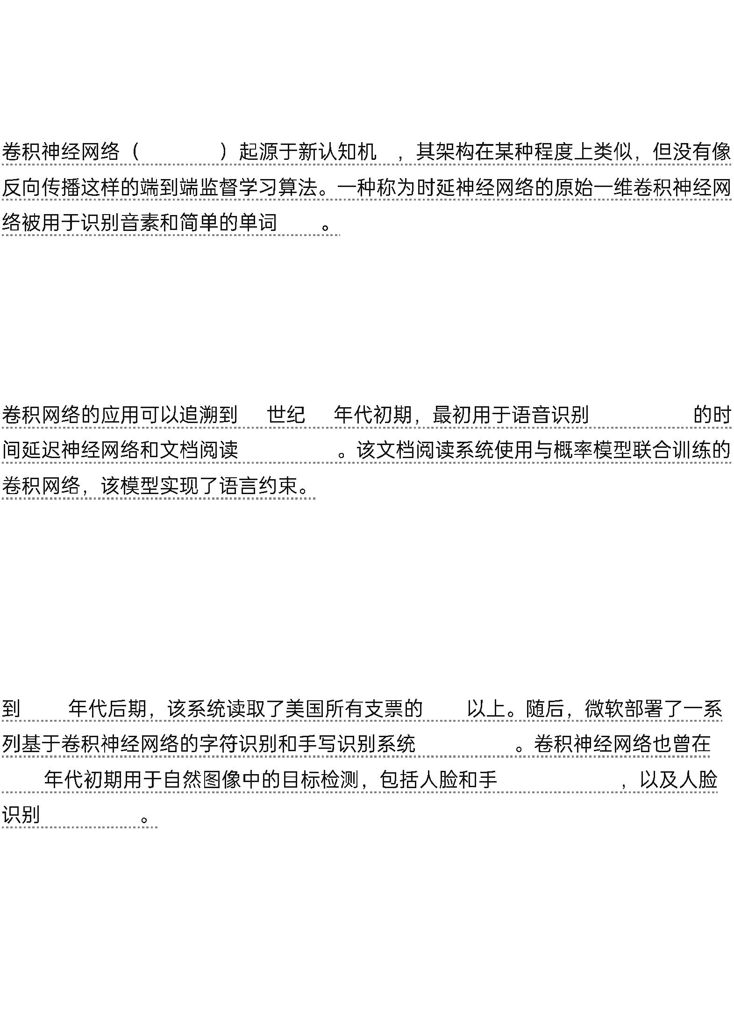

connectomics55, and the detection of faces, text, pedestrians and human bodies in
natural images36,50,51,56–58.
2000
(ConvNets)
5
3
54
6,50,51,56–58
55
3
A major recent practical success of ConvNets is face recognition59.
(ConvNets)
59


Importantly, images can be labelled at the pixel level, which will have applications
in technology, including autonomous mobile robots and self-driving cars60,61.
Companies such as Mobileye and NVIDIA are using such ConvNet-based
methods in their upcoming vision systems for cars. Other applications gaining
importance involve natural language understanding14 and speech recognition7.
6
0,61 Mobileye NVIDIA
14
7
Despite these successes, ConvNets were largely forsaken by the mainstream
computer-vision and machine-learning communities until the ImageNet
competition in 2012. When deep convolutional networks were applied to a data set
of about a million images from the web that contained 1,000 different classes, they
achieved spectacular results, almost halving the error rates of the best competing
approaches1.
2
012 ImageNet
1000
[
NT]1[NT]
This success came from the efficient use of GPUs, ReLUs, a new regularization
technique called dropout62, and techniques to generate more training examples by
deforming the existing ones. This success has brought about a revolution in
computer vision; ConvNets are now the dominant approach for almost all
recognition and detection tasks4,58,59,63–65 and approach human performance
on some tasks.
GPU
ReLU
dropout62
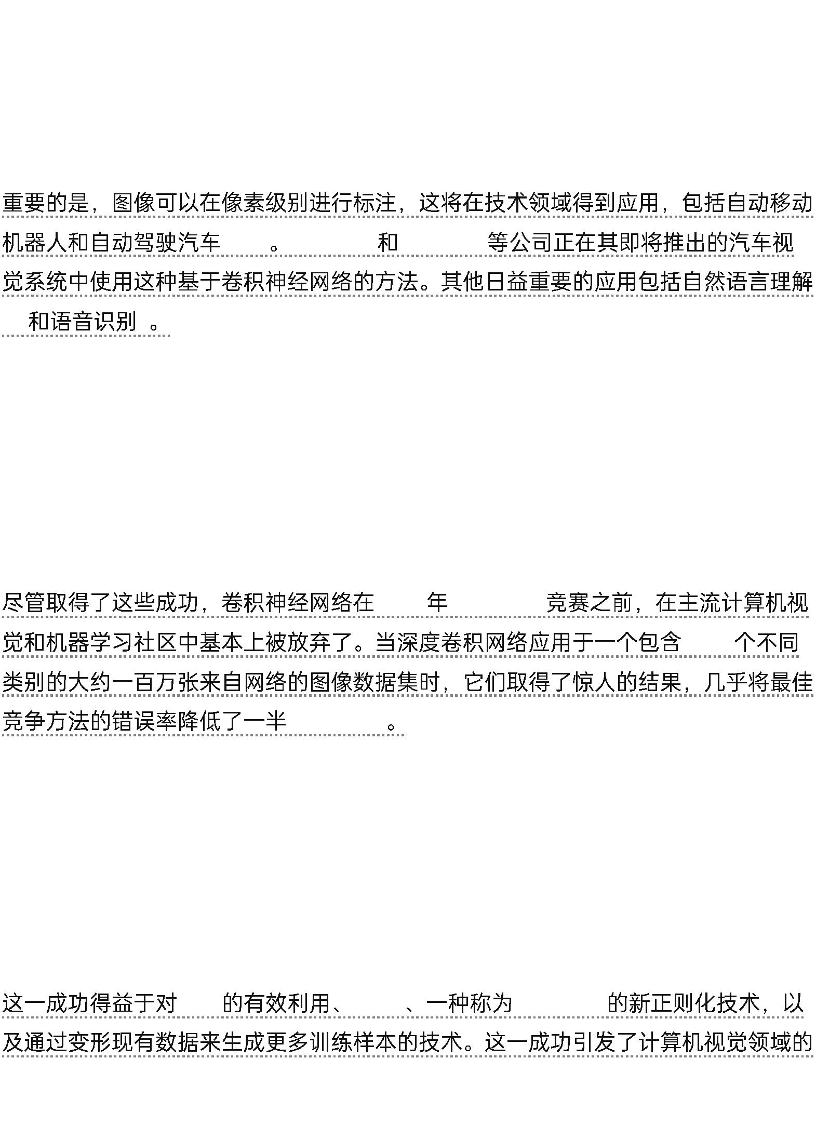

4,58,59,63–65
A recent stunning demonstration combines ConvNets and recurrent net modules
for the generation of image captions (Fig. 3).
3
Recent ConvNet architectures have 10 to 20 layers of ReLUs, hundreds of millions
of weights, and billions of connections between units. Whereas training such large
networks could have taken weeks only two years ago, progress in hardware,
software and algorithm parallelization have reduced training times to a few hours.
10
20
ReLU
The performance of ConvNet-based vision systems has caused most major
technology companies, including Google, Facebook, Microsoft, IBM, Yahoo!,
Twitter and Adobe, as well as a quickly growing number of start-ups to initiate
research and development projects and to deploy ConvNet-based image
understanding products and services.
Facebook
IBM
Twitter Adobe
ConvNets are easily amenable to efficient hardware implementations in chips or
field-programmable gate arrays66,67. A number of companies such as NVIDIA,
Mobileye, Intel, Qualcomm and Samsung are developing ConvNet chips to enable
real-time vision applications in smartphones, cameras, robots and self-driving cars.
ConvNets
66,67
Mobileye
ConvNet
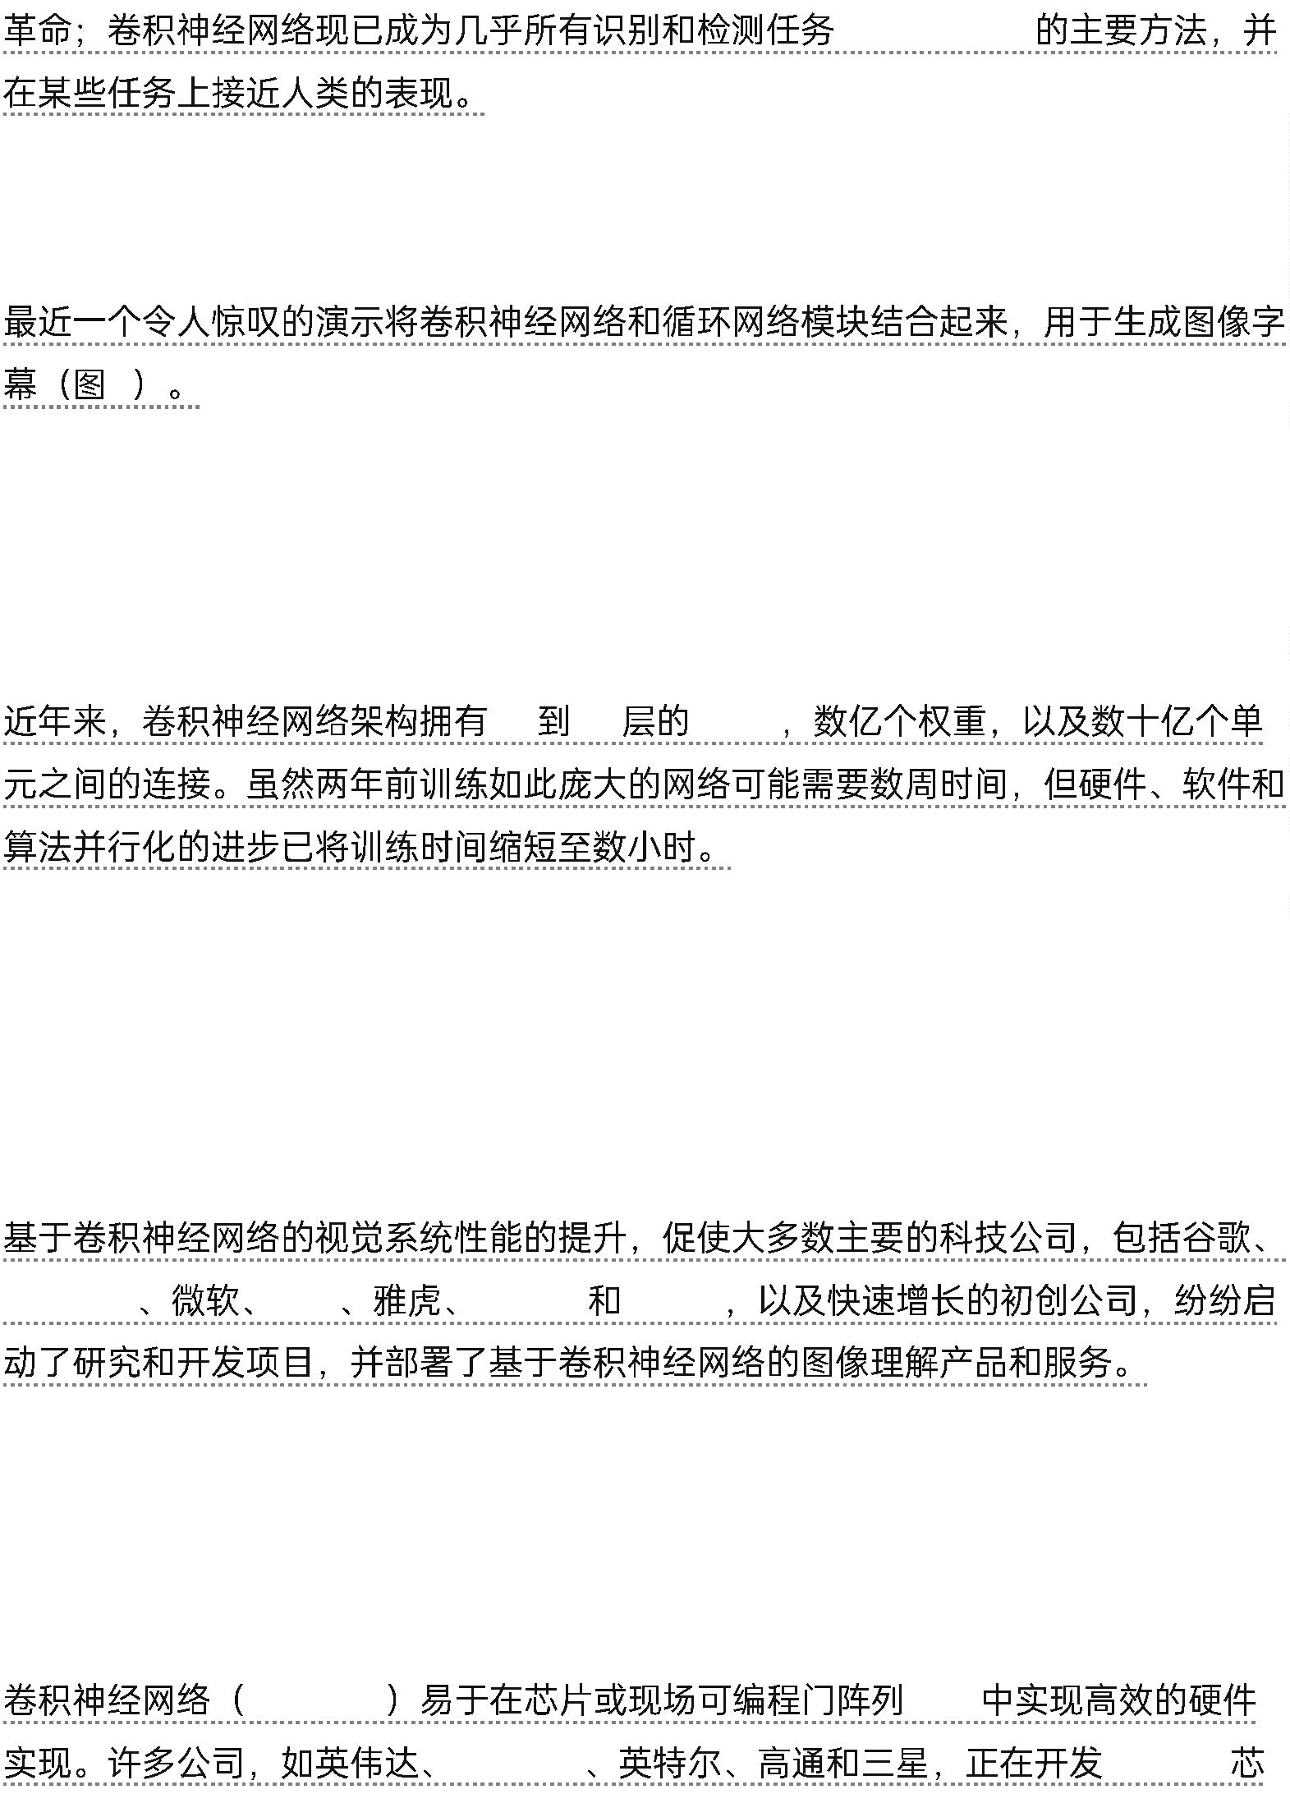

Distributed representations and language processing
Deep-learning theory shows that deep nets have two different exponential
advantages over classic learning algorithms that do not use distributed
2
1
representations . Both of these advantages arise from the power of composition
and depend on the underlying data-generating distribution having an appropriate
4
componential structure .
0
21
4
0
First, learning distributed representations enable generalization to new
combinations of the values of learned features beyond those seen during training
(for example, 2^{n} combinations are possible with n binary features)^{68,69}. Second,
composing layers of representation in a deep net brings the potential for another
exponential advantage70 (exponential in the depth).
2^{n}
n
68,69
7
0
The hidden layers of a multilayer neural network learn to represent the network’s
inputs in a way that makes it easy to predict the target outputs. This is nicely
demonstrated by training a multilayer neural network to predict the next word in a
sequence from a local
[NT]1[NT]
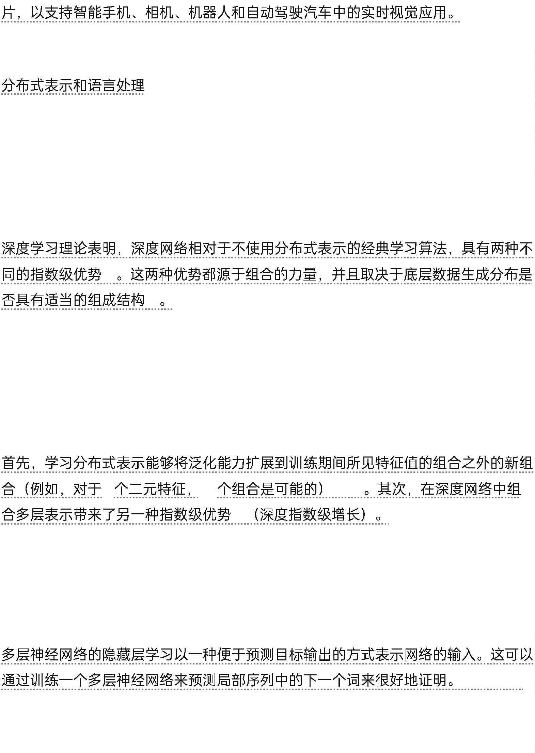

Figure 3 | From image to text. Captions generated by a recurrent neural network
(RNN) taking, as extra input, the representation extracted by a deep convolution
neural network (CNN) from a test image, with the RNN trained to ‘translate’ high-
level representations of images into captions (top).
图3 从图像到文本。由循环神经网络（RNN）生成的标题，该网络以从测试图像中提取的深度卷积神经网络（CNN）的表示作为额外输入，RNN被训练为将图像的高级表示“翻译”成标题（顶部）。
Reproduced with permission from ref. 102. When the RNN is given the ability to
focus its attention on a different location in the input image (middle and bottom;
the lighter patches were given more attention) as it generates each word (bold), we
found86 that it exploits this to achieve better ‘translation’ of images into captions.
经参考文献[NT]102[NT]许可转载。当RNN被赋予在每个单词（粗体）时将注意力集中在输入图像的不同位置（中间和底部；较亮的区域得到更多关注）的能力时，我们发现[NT]86[NT]它利用这一点来实现将图像“翻译”成字幕的更好效果。

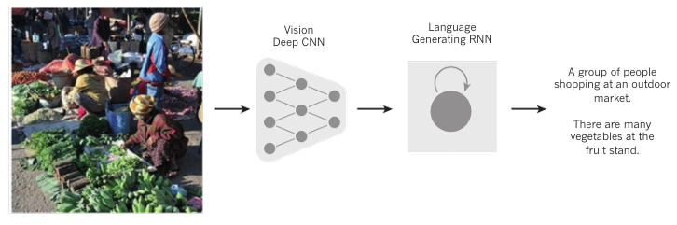


A woman is throwing a frisbee in a park.
一位妇女正在公园扔飞盘。

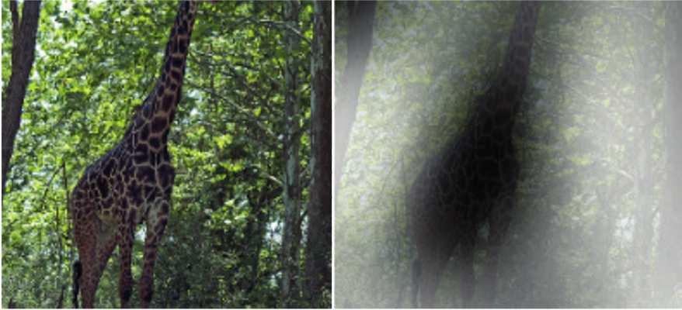

A giraﬀe standing in a forest with trees in the background.
一只长颈鹿站在森林里，背景为众多的树。

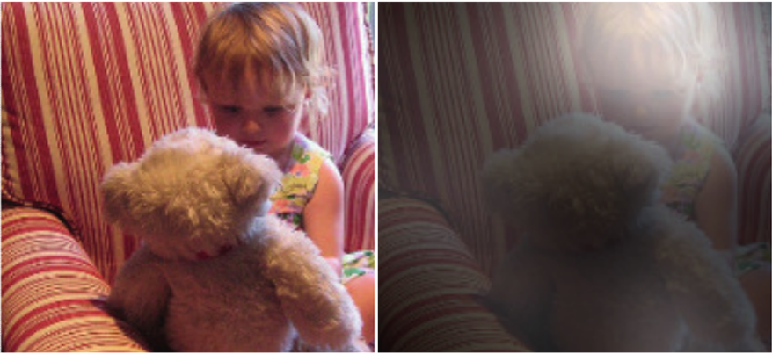

A little girl sitting on a bed with a teddy bear.
一个小女孩带着一只泰迪熊坐在床上。



A group of people sitting on a boat in the water.
一群人坐着一条船在水面上。


A dog is standing on a hardwood ﬂoor.
一只狗站在硬木地板上。

A stop sign is on the road with a mountain in the background.
一个停车标志立在公路上，背景为一座山。

context of earlier words71. Each word in the context is presented to the network as
a one-of-N vector, that is, one component has a value of 1 and the rest are 0. In the
first layer, each word creates a different pattern of activations, or word vectors (Fig.
4). In a language model, the other layers of the network learn to convert the input
word vectors into an output word vector for the predicted next word, which can be
used to predict the probability for any word in the vocabulary to appear as the next
word.

one-of-N
1
0
4
The network learns word vectors that contain many active components each of
which can be interpreted as a separate feature of the word, as was first
demonstrated27 in the context of learning distributed representations for symbols.
These semantic features were not explicitly present in the input.
[
NT]27[NT]
They were discovered by the learning procedure as a good way of factorizing the
structured relationships between the input and output symbols into multiple
‘
micro-rules’. Learning word vectors turned out to also work very well when the
word sequences come from a large corpus of real text and the individual micro-
rules are unreliable71.
“
”
71
When trained to predict the next word in a news story, for example, the learned
word vectors for Tuesday and Wednesday are very similar, as are the word vectors
for Sweden and Norway. Such representations are called distributed
representations because their elements (the features) are not mutually exclusive
and their many configurations correspond to the variations seen in the observed
data.
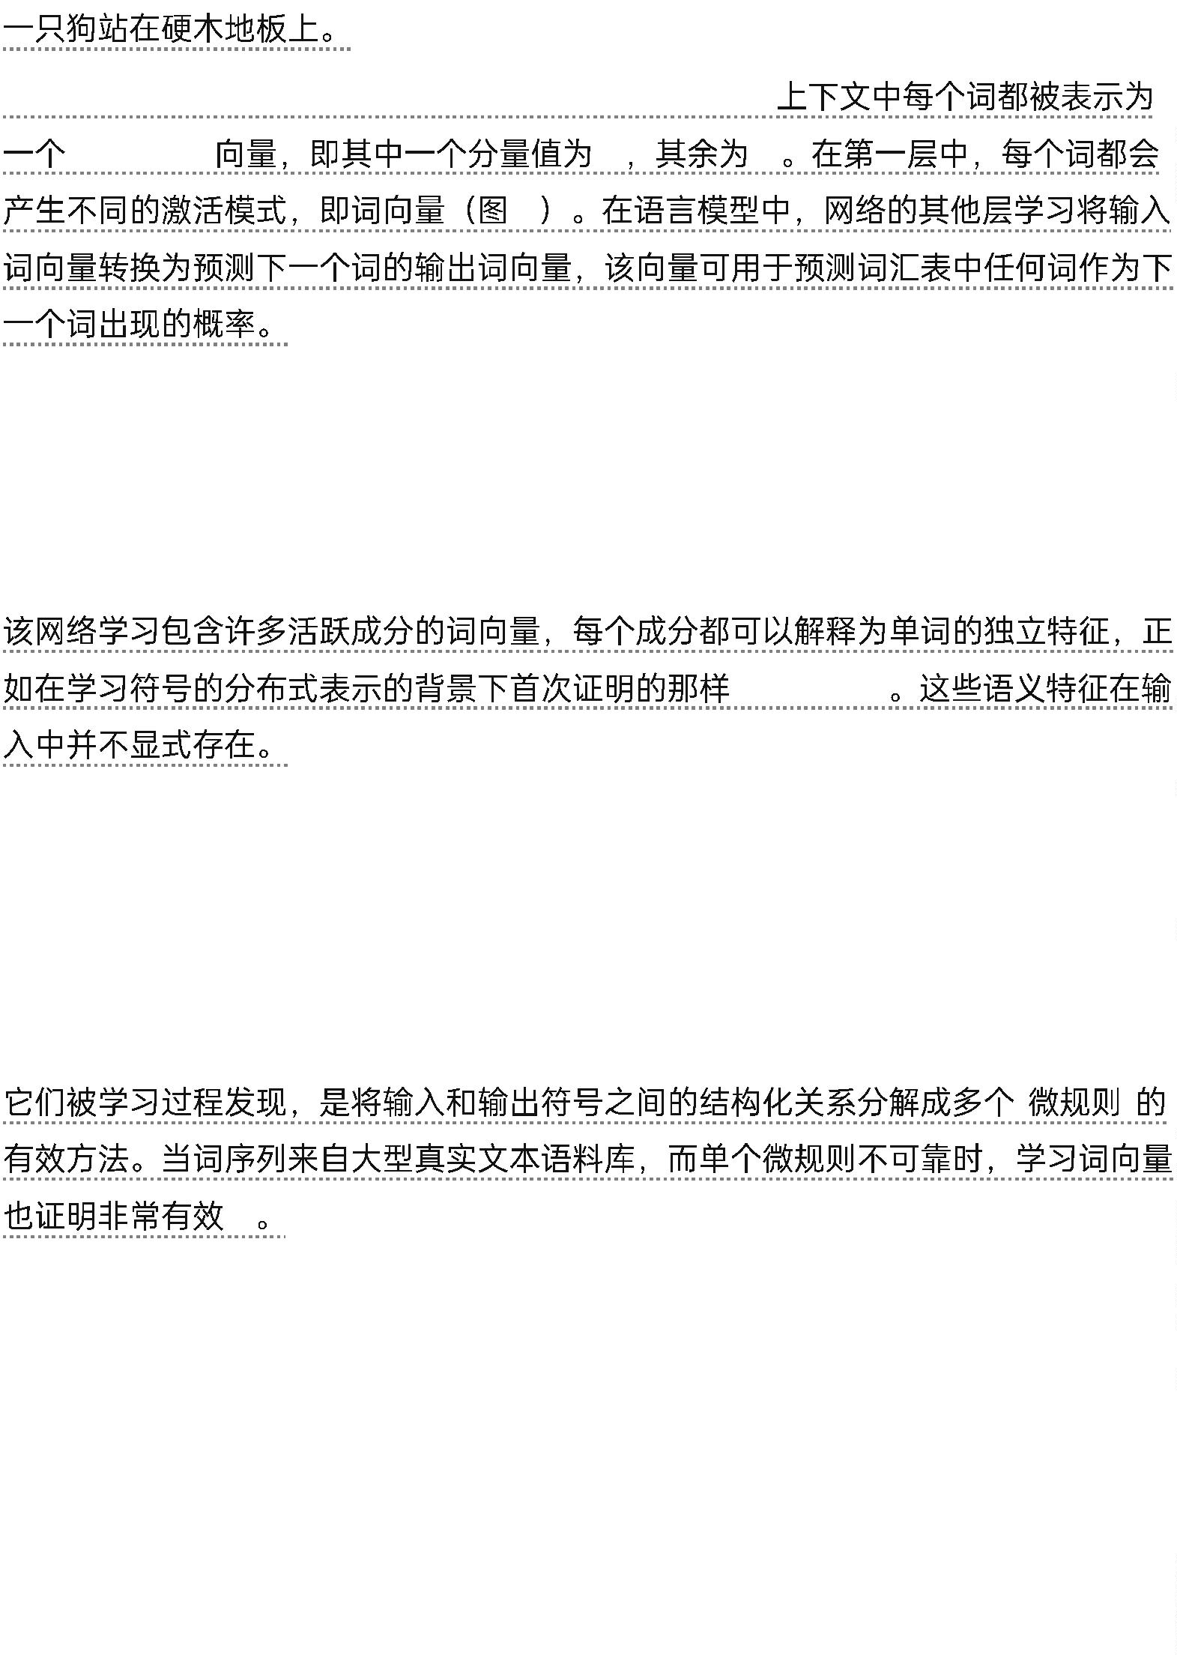

“
” “
”
“
” “
”
These word vectors are composed of learned features that were not determined
ahead of time by experts, but automatically discovered by the neural network.
Vector representations of words learned from text are now very widely used in
natural language applications14,17,72–76.
14,17,72–76
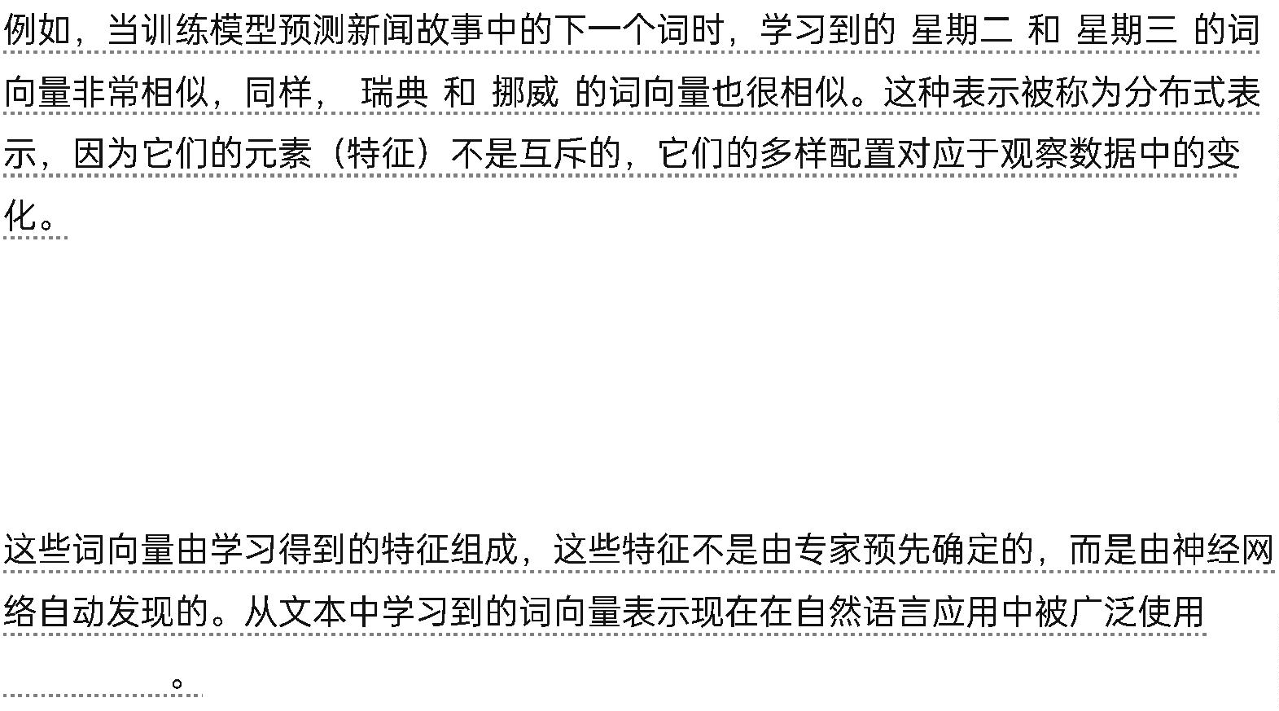

The issue of representation lies at the heart of the debate between the logic-
inspired and the neural-network-inspired paradigms for cognition. In the logic-
inspired paradigm, an instance of a symbol is something for which the only
property is that it is either identical or non-identical to other symbol instances.
It has no internal structure that is relevant to its use; and to reason with symbols,
they must be bound to the variables in judiciously chosen rules of inference. By
contrast, neural networks just use big activity vectors, big weight matrices and
scalar non-linearities to perform the type of fast ‘intuitive’ inference that underpins
effortless commonsense reasoning.
“
”
Before the introduction of neural language models71, the standard approach to
statistical modelling of language did not exploit distributed representations: it was
based on counting frequencies of occurrences of short symbol sequences of length
up to N (called N-grams). The number of possible N-grams is on the order of VN,
where V is the vocabulary size, so taking into account a context of more than a
handful of words would require very large training corpora. N-grams treat each
word as an atomic unit, so they cannot generalize across semantically related
sequences of words, whereas neural language models can because they associate
each word with a vector of real valued features, and semantically related words end
up close to each other in that vector space (Fig. 4).
71
N
N-gram
N-gram
VN
N-gram
V


4
Recurrent neural networks
When backpropagation was first introduced, its most exciting use was for training
recurrent neural networks (RNNs). For tasks that involve sequential inputs, such as
speech and language, it is often better to use RNNs (Fig. 5). RNNs process an input
sequence one element at a time, maintaining in their hidden units a ‘state vector’
that implicitly contains information about the history of all the past elements of the
sequence.
(RNN)
RNN
“
5
RNN
”
When we consider the outputs of the hidden units at different discrete time steps
as if they were the outputs of different neurons in a deep multilayer network (Fig.
5, right), it becomes clear how we can apply backpropagation to train RNNs.
5
RNN
RNNs are very powerful dynamic systems, but training them has proved to be
problematic because the backpropagated gradients either grow or shrink at each
time step, so over many time steps they typically explode or vanish77,78.
RNNs
77,78
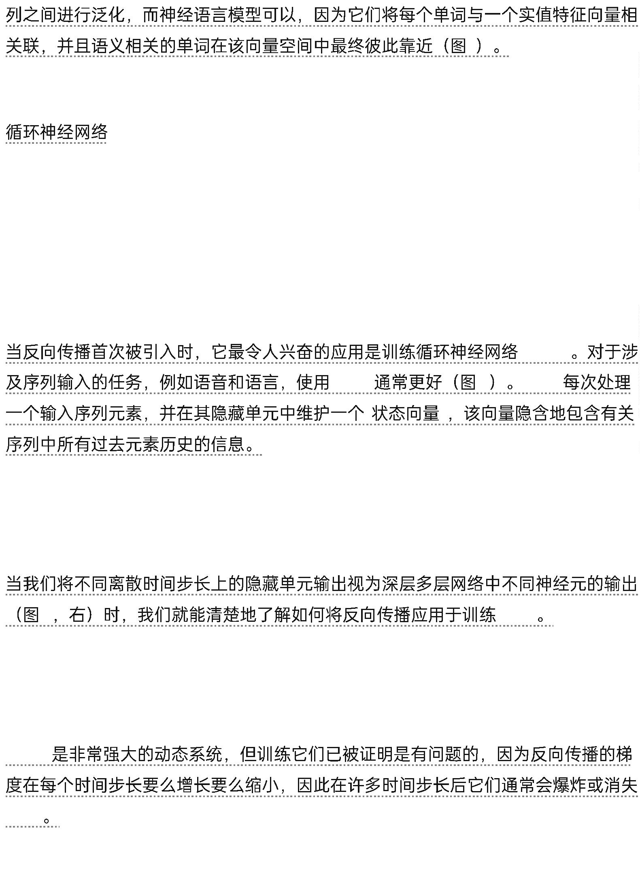

Thanks to advances in their architecture79,80 and ways of training them81,82,
RNNs have been found to be very good at predicting the next character in the
text83 or the next word in a sequence75, but they can also be used for more
complex tasks.
79,80
81,82
75
RNN
83
For example, after reading an English sentence one word at a time, an English
encoder’ network can be trained so that the final state vector of its hidden units is
a good representation of the thought expressed by the sentence.
‘
“
”
This thought vector can then be used as the initial hidden state of (or as extra input
to) a jointly trained French ‘decoder’ network, which outputs a probability
distribution for the first word of the French translation. If a particular first word is
chosen from this distribution and provided as input to the decoder network it will
then output a probability distribution for the second word of the translation and so
on until a full stop is chosen17,72,76.
“
”
17,72,76
Overall, this process generates sequences of French words according to a
probability distribution that depends on the English sentence. This rather naive
way of performing machine translation has quickly become competitive with the
state-of-the-art, and this raises serious doubts about whether understanding a
sentence requires anything like the internal symbolic expressions that are
manipulated by using inference rules.
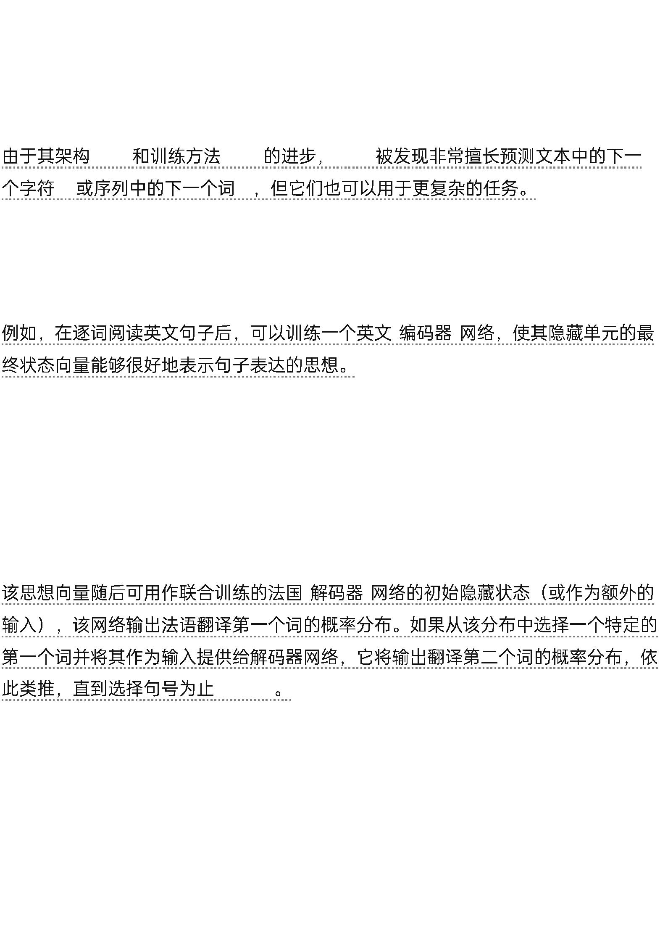

总的来说，这个过程根据依赖于英语句子的概率分布生成法语词序列。。这种相当简单的机器翻译方法很快就与最先进的技术竞争起来，这让人严重怀疑理解句子是否需要类似于使用推理规则所操作的内部符号表达式。

It is more compatible with the view that everyday reasoning involves many simultaneous analogies.

这更符合日常推理涉及许多同时类比的观点。

Figure 4 | Visualizing the learned word vectors. On the left is an illustration of word representations learned for modelling language, non-linearly projected to 2D for visualization using the t-SNE algorithm103. On the right is a 2D representation of phrases learned by an English-to-French encoder–decoder recurrent neural network75.

图4 可视化学习到的词向量。左侧是用于语言建模的词表示的插图，使用t-SNE算法103非线性投影到2D以便可视化。右侧是英语-法语解码器循环神经网络75学习到的短语的2D表示。

One can observe that semantically similar words or sequences of words are mapped to nearby representations. The distributed representations of words are obtained by using backpropagation to jointly learn a representation for each word and a function that predicts a target quantity such as the next word in a sequence(for language modelling) or a whole sequence of translated words (for machine translation)18,75.

可以观察到语义相似的词语或词语序列被映射到附近的表示。词语的分布式表示是通过使用反向传播来联合学习每个词语的表示和一个预测目标量的函数得到的，例如序列中的下一个词语（用于语言建模）或翻译词语的整个序列（用于机器翻译）18,75。

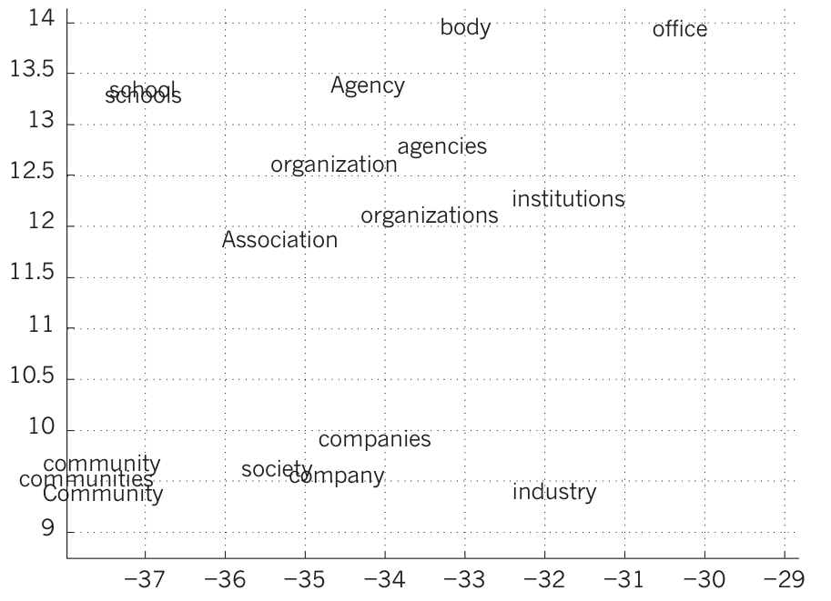

that each contribute plausibility to a conclusion84,85.

每个有助于结论的合理性84,85。

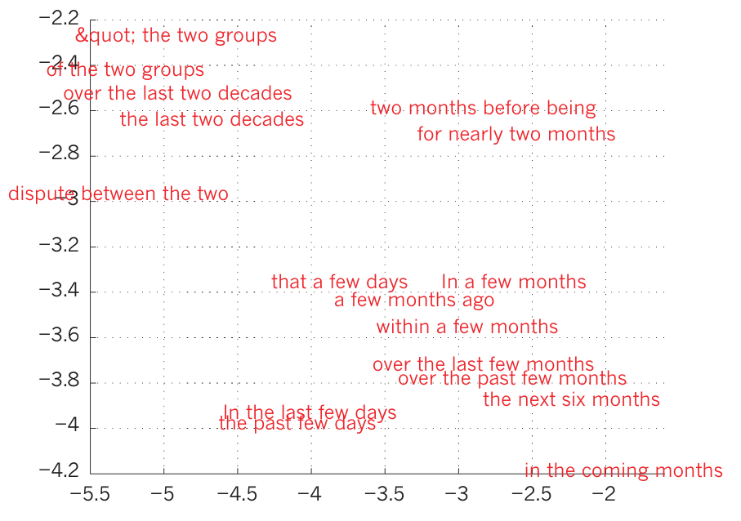

Instead of translating the meaning of a French sentence into an English sentence,
one can learn to ‘translate’ the meaning of an image into an English sentence (Fig.
3). The encoder here is a deep ConvNet that converts the pixels into an activity
vector in its last hidden layer.
“
”
3
The decoder is an RNN similar to the ones used for machine translation and neural
language modelling. There has been a surge of interest in such systems recently
(see examples mentioned in ref. 86).
(RNN)
86
RNNs, once unfolded in time (Fig. 5), can be seen as very deep feedforward
networks in which all the layers share the same weights. Although their main
purpose is to learn long-term dependencies, theoretical and empirical evidence
shows that it is difficult to learn to store information for very long78.
(RNN)
5
78
To correct for that, one idea is to augment the network with an explicit memory.
The first proposal of this kind is the long short-term memory (LSTM) networks
that use special hidden units, the natural behaviour of which is to remember inputs
for a long time79.
(LSTM)
79


A special unit called the memory cell acts like an accumulator or a gated leaky
neuron: it has a connection to itself at the next time step that has a weight of one,
so it copies its own real-valued state and accumulates the external signal, but this
self-connection is multiplicatively gated by another unit that learns to decide when
to clear the content of the memory.
1
LSTM networks have subsequently proved to be more effective than conventional
RNNs, especially when they have several layers for each time step87, enabling an
entire speech recognition system that goes all the way from acoustics to the
sequence of characters in the transcription.
LSTM
RNN
87
LSTM networks or related forms of gated units are also currently used for the
encoder and decoder networks that perform so well at machine
translation17,72,76.
LSTM
17,72,76
Over the past year, several authors have made different proposals to augment
RNNs with a memory module. Proposals include the Neural Turing Machine in
which the network is augmented by a ‘tape-like’ memory that the RNN can choose
to read from or write to88, and memory networks, in which a regular network is
augmented by a kind of associative memory89.
RNN
“
”
RNN
8
8
89
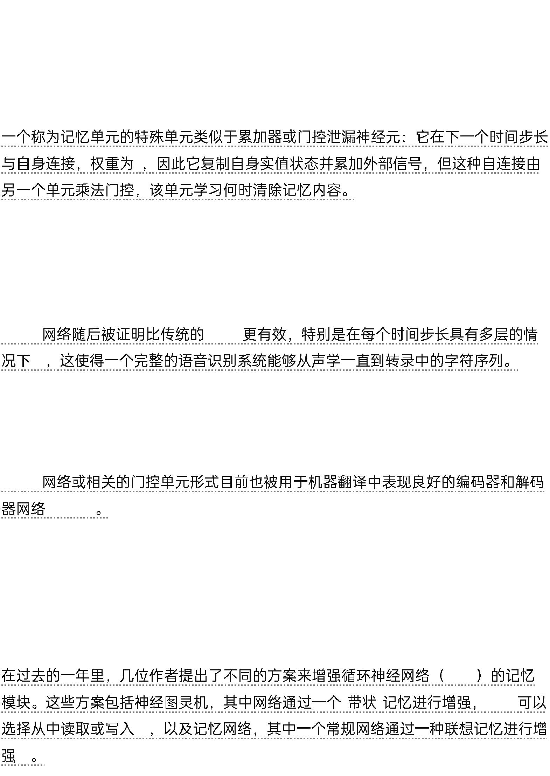

Memory networks have yielded excellent performance on standard question-
answering benchmarks. The memory is used to remember the story about which
the network is later asked to answer questions.
Beyond simple memorization, neural Turing machines and memory networks are
being used for tasks that would normally require reasoning and symbol
manipulation. Neural Turing machines can be taught ‘algorithms’. Among other
things, they can learn to output a sorted list of symbols when their input consists of
an unsorted sequence in which each symbol is accompanied by a real value that
indicates its priority in the list88. Memory networks can be trained to keep track of
the state of the world in a setting similar to a text adventure game and after reading
a story, they can answer questions that require complex inference90.
“
”
8
8
90
In one test example, the network is shown a 15-sentence version of the The Lord of
the Rings and correctly answers questions such as “where is Frodo now?”89.
15
“
”89
The future of deep learning
Unsupervised learning91–98 had a catalytic effect in reviving interest in deep
learning, but has since been overshadowed by the successes of purely supervised


learning. Although we have not focused on it in this Review, we expect
unsupervised learning to become far more important in the longer term.
91–98
Human and animal learning is largely unsupervised: we discover the structure of
the world by observing it, not by being told the name of every object.
Human vision is an active process that sequentially samples the optic array in an
intelligent, task-speciﬁc way using a small, high-resolution fovea with a large, low-
resolution surround. We expect much of the future progress in vision to come
from systems that are trained end-toend and combine ConvNets with RNNs that
use reinforcement learning to decide where to look.
Systems combining deep learning and reinforcement learning are in their infancy,
but they already outperform passive vision systems99 at classification tasks and
produce impressive results in learning to play many different video games100.
99
100
Natural language understanding is another area in which deep learning is poised to
make a large impact over the next few years. We expect systems that use RNNs to


understand sentences or whole documents will become much better when they
learn strategies for selectively attending to one part at a time76,86.
RNN
76,86
Ultimately, major progress in artificial intelligence will come about through
systems that combine representation learning with complex reasoning. Although
deep learning and simple reasoning have been used for speech and handwriting
recognition for a long time, new paradigms are needed to replace rule-based
manipulation of symbolic expressions by operations on large vectors¹⁰¹.
■
101
vectors .
■
Received 25 February; accepted 1 May 2015.
2
25
2015
5
1
1. Krizhevsky, A., Sutskever, I. & Hinton, G. ImageNet classification with
deep convolutional neural networks.In Proc.Advances in Neural
Information Processing Systems 25 1090–1098 (2012).
This report was a breakthrough that used convolutional nets to
almost halve the error rate for object recognition, and precipitated
the rapid adoption of deep learning by the computer vision
community.
2
. Farabet, C., Couprie, C., Najman, L. & LeCun, Y. Learning hierarchical
features for scene labeling.IEEE Trans.Pattern Anal.Mach.Intell. 35,
915–1929 (2013).
1
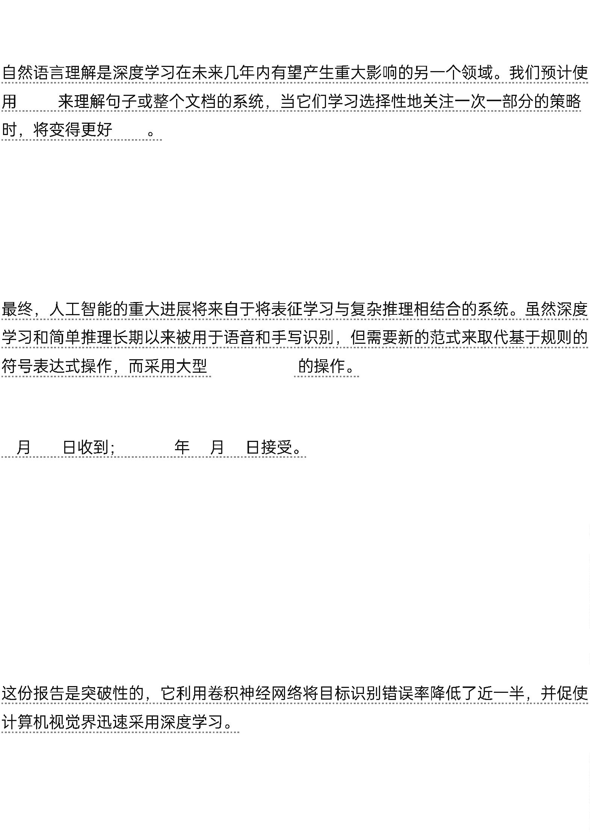

3. Tompson, J., Jain, A., LeCun, Y. & Bregler, C. Joint training of a
convolutional network and a graphical model for human pose
estimation.In Proc. Advances in Neural Information Processing Systems
27 1799–1807 (2014).
4. Szegedy, C. et al. Going deeper with convolutions.Preprint at http://a
rxiv.org/ abs/1409.4842(2014).
5. Mikolov, T., Deoras, A., Povey, D., Burget, L. & Cernocky, J. Strategies
for training large scale neural network language models.In
Proc.Automatic Speech Recognition and Understanding 196–201 (2011).
6. Hinton, G. et al. Deep neural networks for acoustic modeling in
speech recognition.IEEE Signal Processing Magazine 29, 82–97 (2012).
This joint paper from the major speech recognition laboratories,
summarizing the breakthrough achieved with deep learning on the
task of phonetic classification for automatic speech recognition, was
the first major industrial application of deep learning.
6
. Hinton, G.
.
. IEEE
29,
8
2–97 (2012).
7. Sainath, T., Mohamed, A.-R.,Kingsbury, B. & Ramabhadran, B. Deep
convolutional neural networks for LVCSR.In Proc.Acoustics, Speech and
Signal Processing 8614–8618 (2013).
8. Ma, J., Sheridan, R. P., Liaw, A., Dahl, G. E. & Svetnik, V. Deep neural
nets as a method for quantitative structure-activity relationships.J.
Chem.Inf. Model.55, 263–274 (2015).
9. Ciodaro, T., Deva, D., de Seixas, J. & Damazio, D. Online particle
detection with neural networks based on topological calorimetry
information.J. Phys.Conf. Series 368, 012030 (2012).
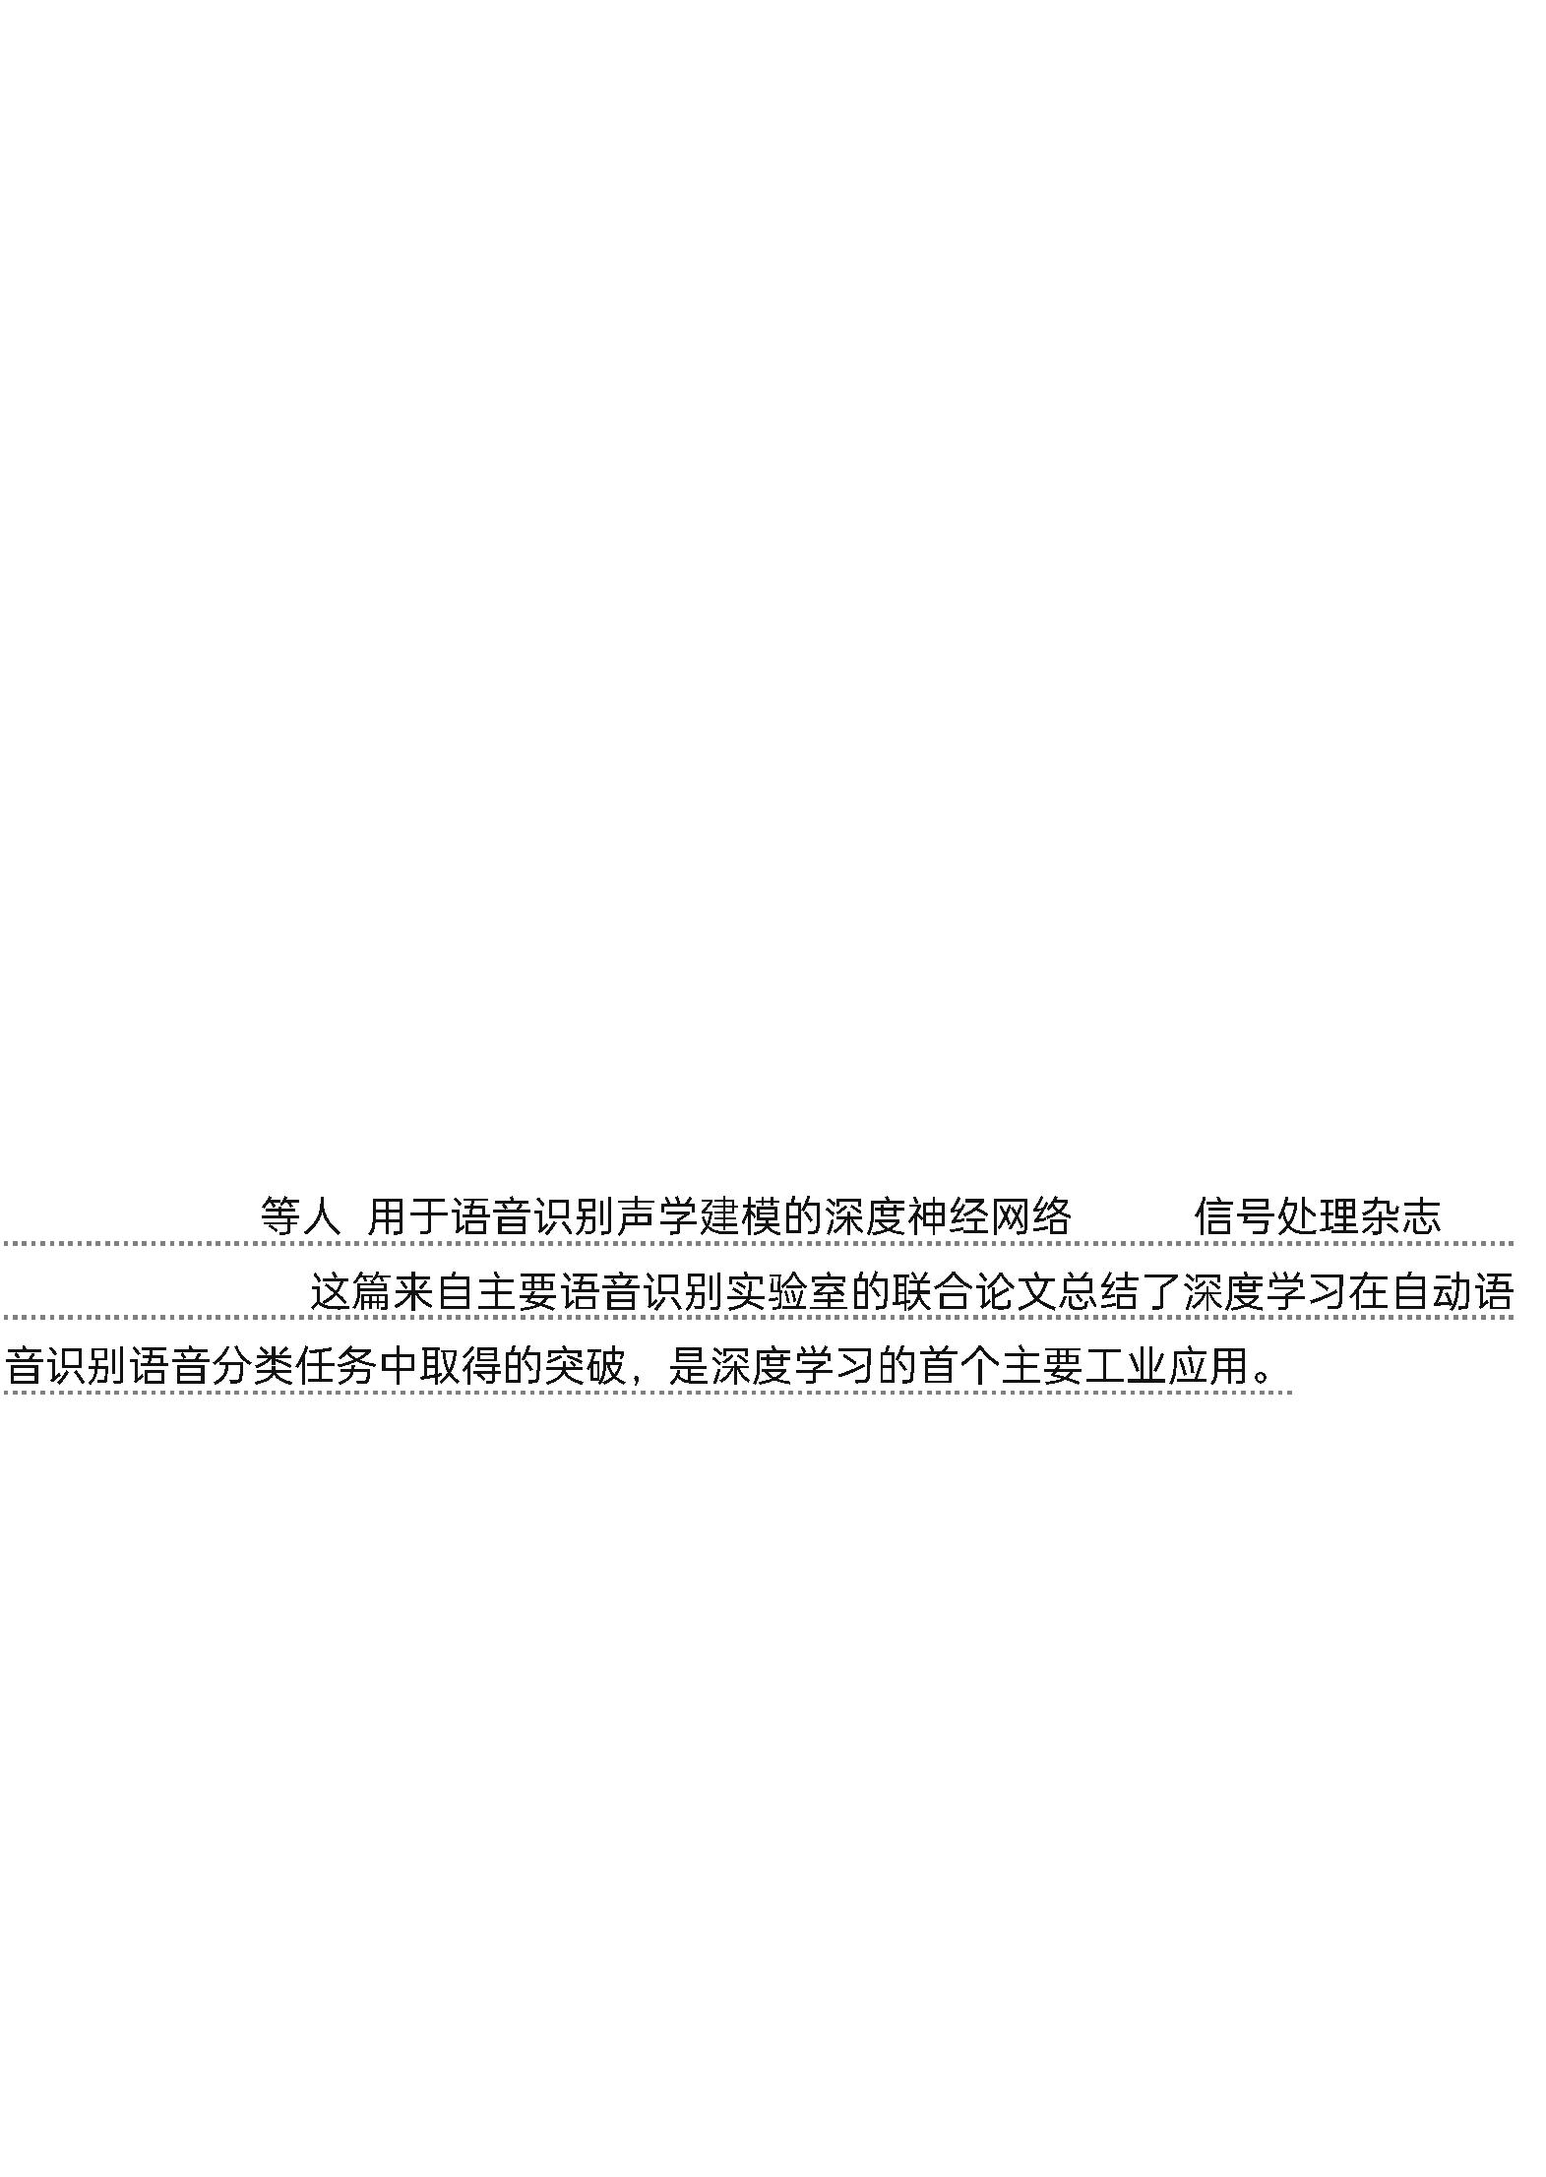

10. Kaggle.Higgs boson machine learning challenge.Kaggle https://ww
w.kaggle. com/c/higgs-boson (2014).
11. Helmstaedter, M. et al. Connectomic reconstruction of the inner
plexiform layer in the mouse retina.Nature 500, 168–174 (2013).

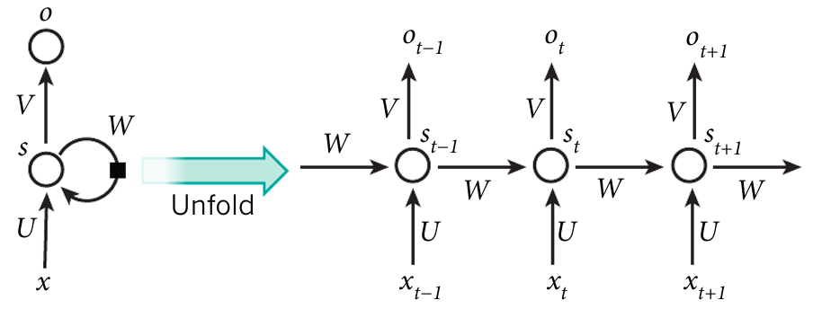

Figure 5 | A recurrent neural network and the unfolding in time of the computation involved in its
forward computation. The artificial neurons (for example, hidden units grouped under node s with
values s_{t} at time t) get inputs from other neurons at previous time steps (this is represented with the
black square, representing a delay of one time step, on the left). In this way, a recurrent neural network
can map an input sequence with elements x into an output sequence with elements o_{t} , with each o_{t}
depending on all the previous x_{t}ʹ (for tʹ ≤ t). The same parameters (matrices U ,V,W ) are used at each
time step. Many other architectures are possible, including a variant in which the network can generate
a sequence of outputs (for example, words), each of which is used as inputs for the next time step. The
backpropagation algorithm (Fig. 1) can be directly applied to the computational graph of the unfolded
network on the right, to compute the derivative of a total error (for example, the log-probability of
generating the right sequence of outputs) with respect to all the states s_{t} and all the parameters.

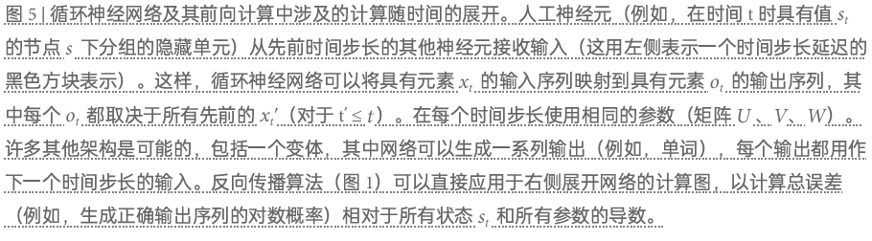

12. Leung, M. K., Xiong, H. Y., Lee, L. J. & Frey, B. J. Deep learning of
the tissueregulated splicing code.Bioinformatics 30, i121–i129 (2014).
13. Xiong, H. Y. et al. The human splicing code reveals new insights
into the genetic determinants of disease.Science 347, 6218 (2015).
14. Collobert, R., et al. Natural language processing (almost) from
scratch.J. Mach. Learn.Res.12, 2493–2537 (2011).
15. Bordes, A., Chopra, S. & Weston, J. Question answering with
subgraph embeddings.In Proc. Empirical Methods in Natural Language
Processing http:// arxiv.org/abs/1406.3676v3(2014).
16. Jean, S., Cho, K., Memisevic, R. & Bengio, Y. On using very large
target vocabulary for neural machine translation.In Proc. ACL-IJCNLP ht
tp://arxiv.org/ abs/1412.2007(2015).
17. Sutskever, I. Vinyals, O. & Le. Q. V. Sequence to sequence learning
with neural networks.In Proc.Advances in Neural Information Processing
Systems 27 3104–3112 (2014).
This paper showed state-of-the-art machine translation results with
the architecture introduced in ref. 72, with a recurrent network
trained to read a sentence in one language, produce a semantic
representation of its meaning, and generate a translation in another
language.
[
72]
18. Bottou, L. & Bousquet, O. The tradeoffs of large scale learning.In
Proc.Advances in Neural Information Processing Systems 20 161–168
(2007).


19. Duda, R. O. & Hart, P. E. Pattern Classiﬁcation and Scene Analysis
(Wiley, 1973).
20. Schölkopf, B. & Smola, A. Learning with Kernels (MIT Press, 2002).
21. Bengio, Y., Delalleau, O. & Le Roux, N. The curse of highly variable
functions for local kernel machines.In Proc.Advances in Neural
Information Processing Systems 18 107–114 (2005).
22. Selfridge, O. G. Pandemonium: a paradigm for learning in
mechanisation of thought processes.In Proc.Symposium on
Mechanisation of Thought Processes 513–526 (1958).
23. Rosenblatt, F. The Perceptron — A Perceiving and Recognizing
Automaton. Tech. Rep.85-460-1 (Cornell Aeronautical Laboratory,
1957).
24. Werbos, P. Beyond Regression: New Tools for Prediction and Analysis
in the Behavioral Sciences. PhD thesis, Harvard Univ. (1974).
25. Parker, D. B. Learning Logic Report TR–47 (MIT Press, 1985).
26. LeCun, Y. Une procédure d’apprentissage pour Réseau à seuil
assymétrique in Cognitiva 85: a la Frontière de l’Intelligence Artiﬁcielle,
des Sciences de la Connaissance et des Neurosciences [in French] 599–
604 (1985).
27. Rumelhart, D. E., Hinton, G. E. & Williams, R. J. Learning
representations by back-propagating errors.Nature 323, 533–536
(1986).
28. Glorot, X., Bordes, A. & Bengio.Y. Deep sparse rectiﬁer neural
networks.In Proc. 14th International Conference on Artificial Intelligence
and Statistics 315–323 (2011).


This paper showed that supervised training of very deep neural
networks is much faster if the hidden layers are composed of ReLU.
ReLU
29. Dauphin, Y. et al. Identifying and attacking the saddle point
problem in highdimensional non-convex optimization.In Proc.Advances
in Neural Information Processing Systems 27 2933–2941 (2014).
30. Choromanska, A., Henaff, M., Mathieu, M., Arous, G. B. & LeCun, Y.
The loss surface of multilayer networks.In Proc.Conference on AI and
Statistics http:// arxiv.org/abs/1412.0233(2014).
31. Hinton, G. E. What kind of graphical model is the brain? In
Proc.19th International Joint Conference on Artificial intelligence 1765–
1775 (2005).
32. Hinton, G. E., Osindero, S. & Teh, Y.-W.A fast learning algorithm for
deep belief nets.Neural Comp.18, 1527–1554 (2006). This paper
introduced a novel and effective way of training very deep neural
networks by pre-training one hidden layer at a time using the
unsupervised learning procedure for restricted Boltzmann machines.
3
2. Hinton, G. E., Osindero, S. & Teh, Y.-W.
Comp. 18, 1527–1554 (2006).
. Neural
33. Bengio, Y., Lamblin, P., Popovici, D. & Larochelle, H. Greedy layer-
wise training of deep networks.In Proc. Advances in Neural Information
Processing Systems 19 153–160 (2006).
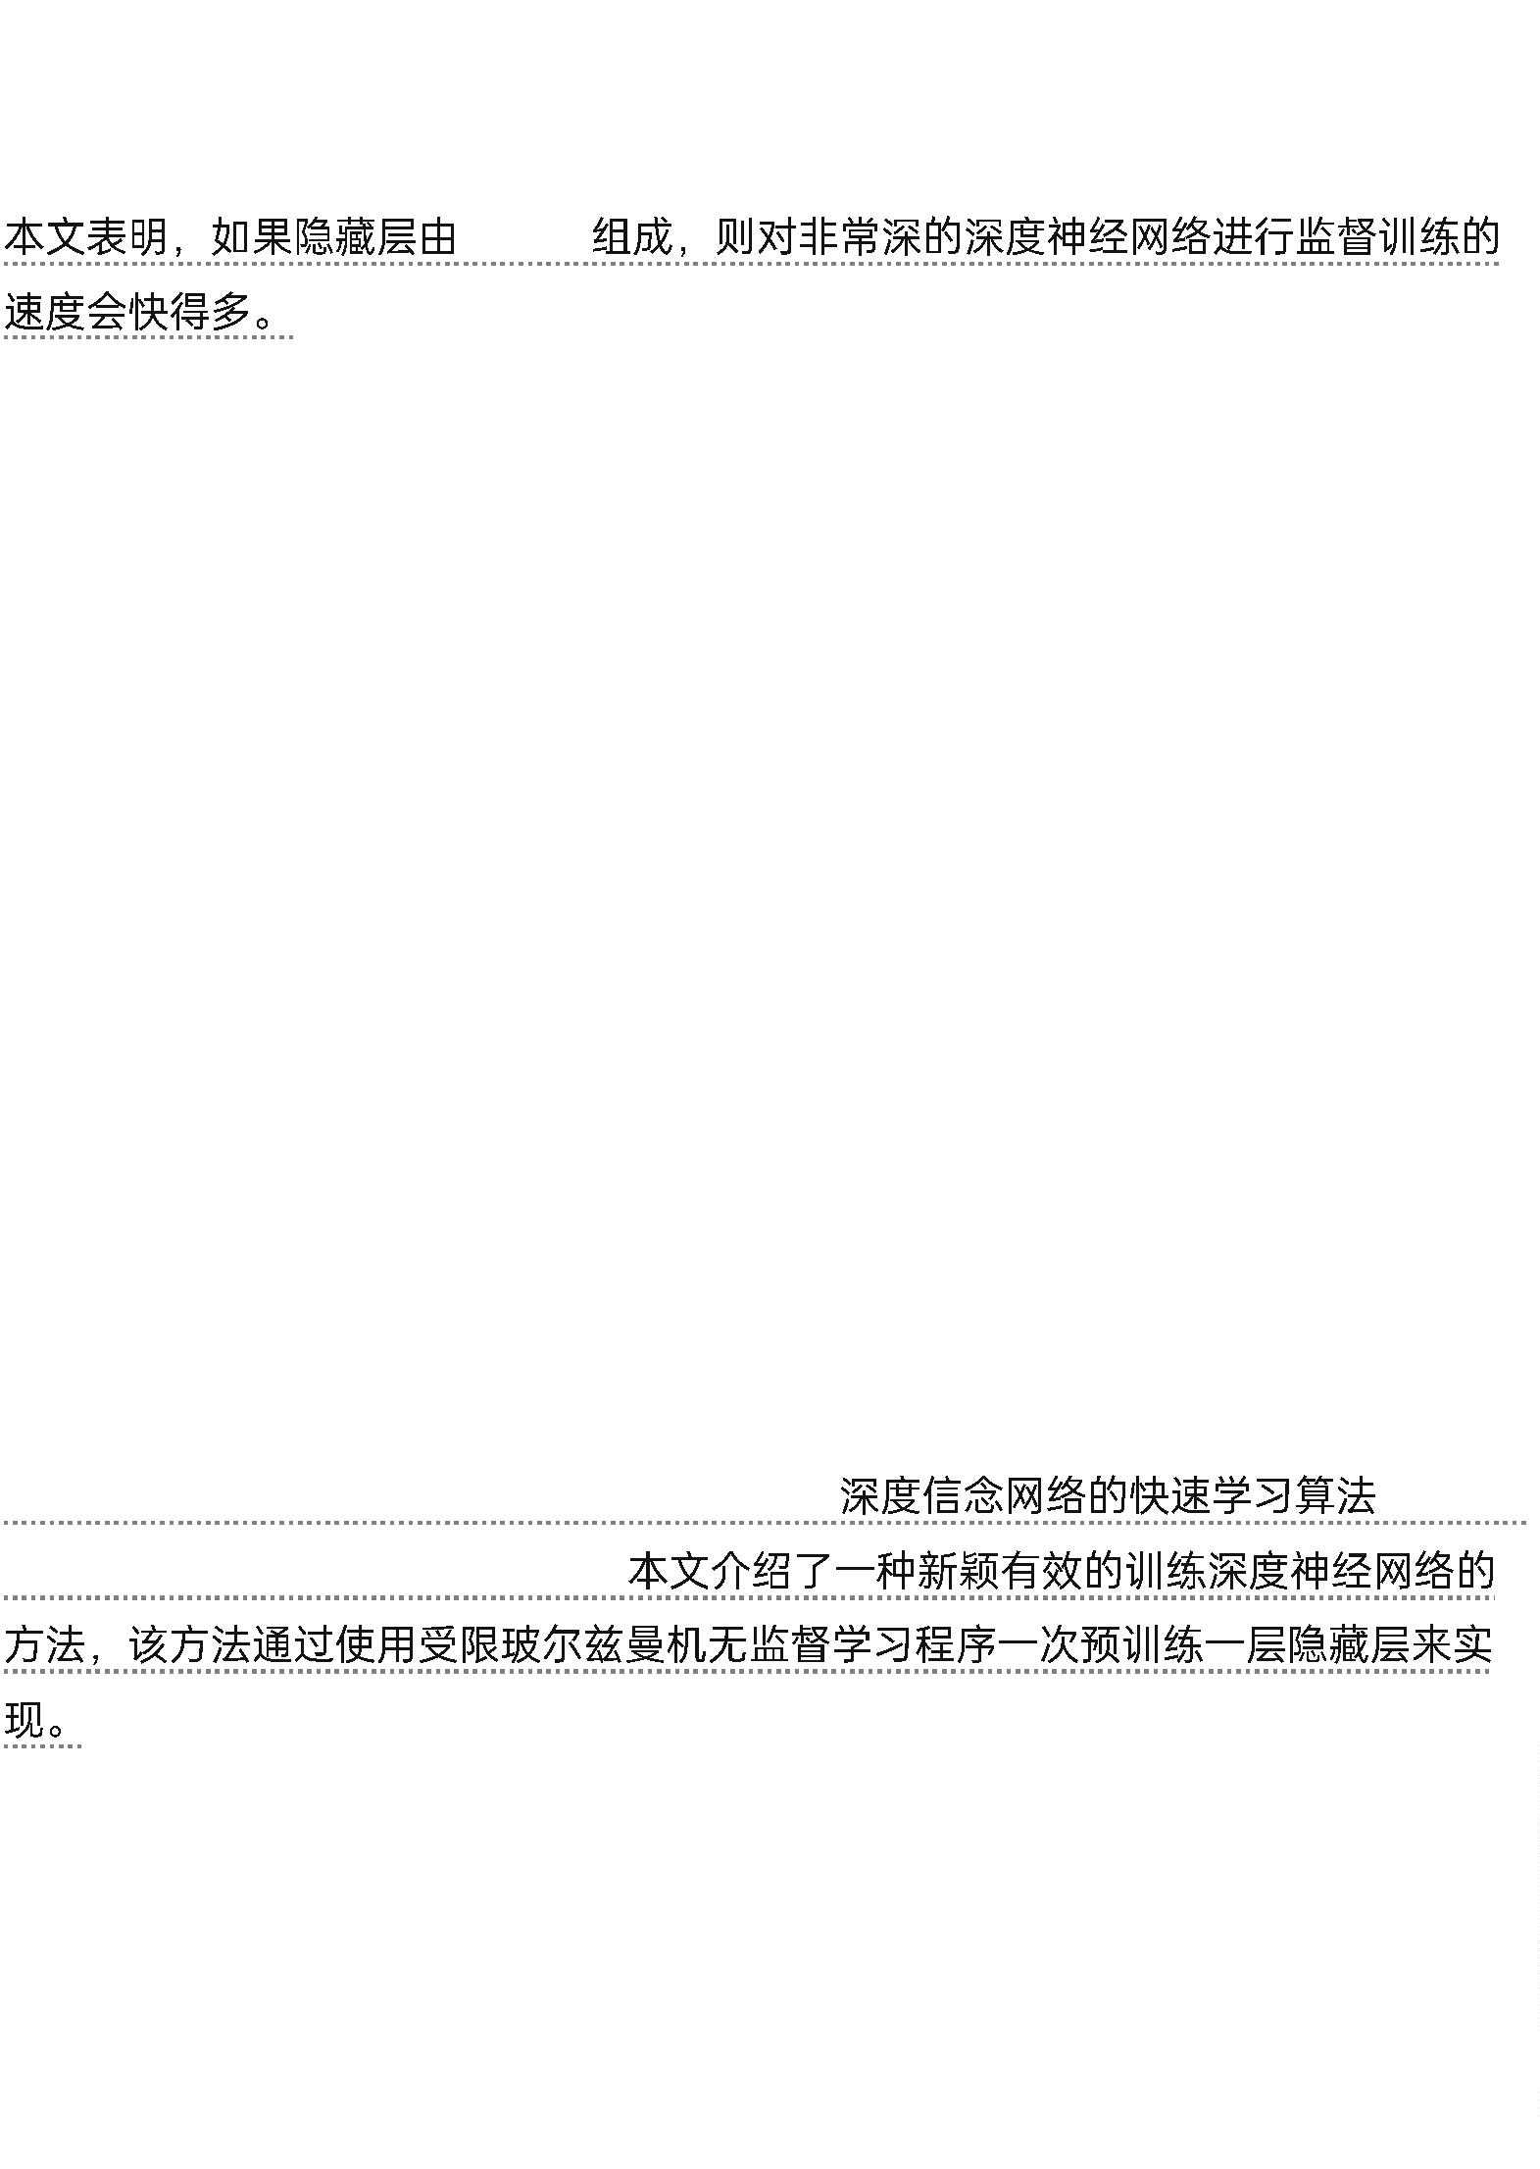

This report demonstrated that the unsupervised pre-training method
introduced in ref. 32 significantly improves performance on test data
and generalizes the method to other unsupervised representation-
learning techniques, such as auto-encoders.
32
34. Ranzato, M., Poultney, C., Chopra, S. & LeCun, Y. Efﬁcient learning
of sparse representations with an energy-based model.In Proc.
Advances in Neural Information Processing Systems 19 1137–1144
(2006).
35. Hinton, G. E. & Salakhutdinov, R. Reducing the dimensionality of
data with neural networks.Science 313, 504–507 (2006).
36. Sermanet, P., Kavukcuoglu, K., Chintala, S. & LeCun, Y. Pedestrian
detection with unsupervised multi-stage feature learning.In
Proc.International Conference on Computer Vision and Pattern
Recognition http://arxiv.org/abs/1212.0142 (2013).
37. Raina, R., Madhavan, A. & Ng, A. Y. Large-scale deep unsupervised
learning using graphics processors.In Proc.26th Annual International
Conference on Machine Learning 873–880 (2009).
38. Mohamed, A.-R.,Dahl, G. E. & Hinton, G. Acoustic modeling using
deep belief networks.IEEE Trans.Audio Speech Lang.Process.20, 14–22
(2012).
39. Dahl, G. E., Yu, D., Deng, L. & Acero, A. Context-dependent pre-
trained deep neural networks for large vocabulary speech
recognition.IEEE Trans.Audio Speech Lang.Process.20, 33–42 (2012).
40. Bengio, Y., Courville, A. & Vincent, P. Representation learning: a
review and new perspectives.IEEE Trans.Pattern Anal.Machine Intell.35,


1798–1828 (2013).
41. LeCun, Y. et al. Handwritten digit recognition with a back-
propagation network. In Proc.Advances in Neural Information Processing
Systems 396–404 (1990). This is the first paper on convolutional
networks trained by backpropagation for the task of classifying low-
resolution images of handwritten digits.
42. LeCun, Y., Bottou, L., Bengio, Y. & Haffner, P. Gradient-based
learning applied to document recognition.Proc.IEEE 86, 2278–2324
(1998).
This overview paper on the principles of end-to-end training of
modular systems such as deep neural networks using gradient-based
optimization showed how neural networks (and in particular
convolutional nets) can be combined with search or inference
mechanisms to model complex outputs that are interdependent, such
as sequences of characters associated with the content of a
document.
43. Hubel, D. H. & Wiesel, T. N. Receptive ﬁelds, binocular interaction,
and functional architecture in the cat’s visual cortex. J. Physiol.160,
106–154 (1962).
44. Felleman, D. J. & Essen, D. C. V. Distributed hierarchical processing
in the primate cerebral cortex. Cereb.Cortex 1, 1–47 (1991).
45. Cadieu, C. F. et al. Deep neural networks rival the representation of
primate it cortex for core visual object recognition.PLoS Comp.Biol.10,
e1003963 (2014).
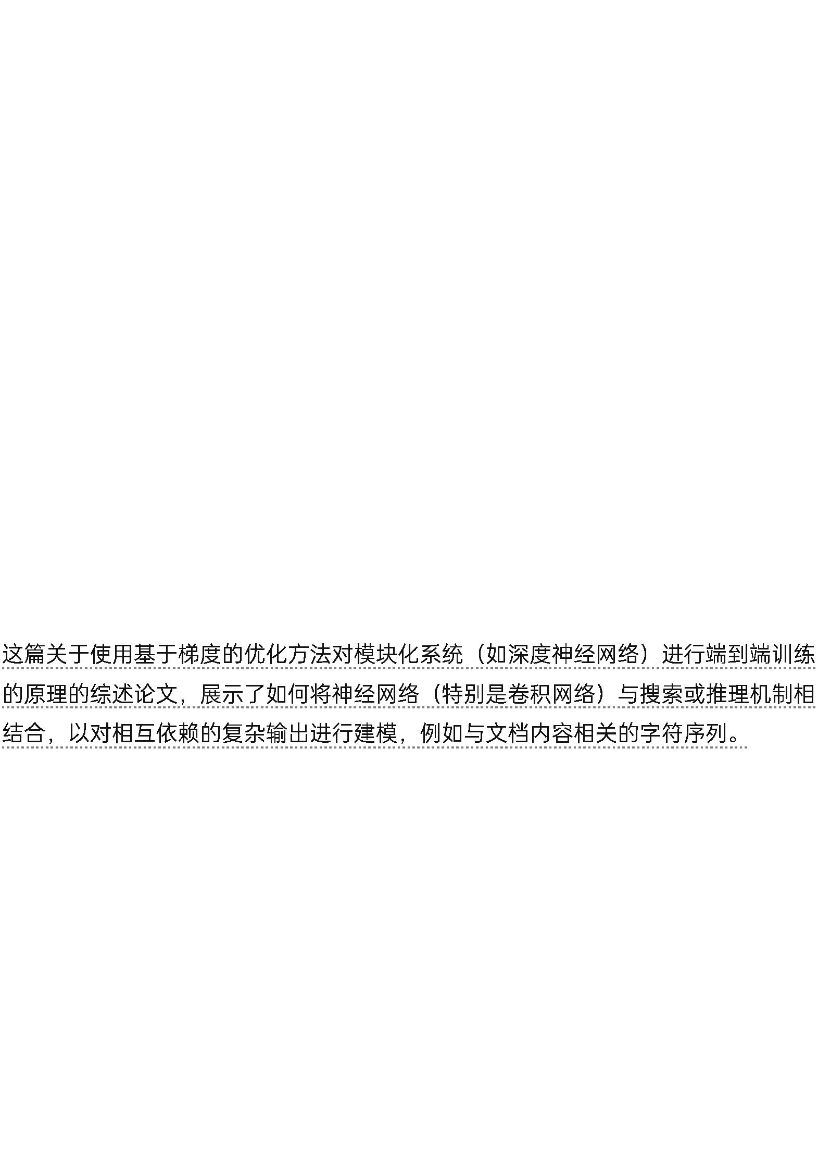

46. Fukushima, K. & Miyake, S. Neocognitron: a new algorithm for
pattern recognition tolerant of deformations and shifts in
position.Pattern Recognition 15, 455–469 (1982).
47. Waibel, A., Hanazawa, T., Hinton, G. E., Shikano, K. & Lang, K.
Phoneme recognition using time-delay neural networks.IEEE
Trans.Acoustics Speech Signal Process.37, 328–339 (1989).
48. Bottou, L., Fogelman-Soulié, F., Blanchet, P. & Lienard, J.
Experiments with time delay networks and dynamic time warping for
speaker independent isolated digit recognition.In Proc.EuroSpeech 89
537–540 (1989).
49. Simard, D., Steinkraus, P. Y. & Platt, J. C. Best practices for
convolutional neural networks.In Proc. Document Analysis and
Recognition 958–963 (2003).
50. Vaillant, R., Monrocq, C. & LeCun, Y. Original approach for the
localisation of objects in images.In Proc.Vision, Image, and Signal
Processing 141, 245–250 (1994).
51. Nowlan, S. & Platt, J. in Neural Information Processing Systems 901–
908 (1995).
52. Lawrence, S., Giles, C. L., Tsoi, A. C. & Back, A. D. Face recognition:
a convolutional neural-network approach.IEEE Trans.Neural Networks 8,
98–113 (1997).
53. Ciresan, D., Meier, U. Masci, J. & Schmidhuber, J. Multi-column
deep neural network for trafﬁc sign classiﬁcation.Neural Networks 32,
333–338 (2012).
54. Ning, F. et al. Toward automatic phenotyping of developing
embryos from videos.IEEE Trans.Image Process.14, 1360–1371 (2005).

55. Turaga, S. C. et al. Convolutional networks can learn to generate
afﬁnity graphs for image segmentation.Neural Comput.22, 511–538
(2010).
56. Garcia, C. & Delakis, M. Convolutional face ﬁnder: a neural
architecture for fast and robust face detection.IEEE Trans.Pattern
Anal.Machine Intell.26, 1408–1423 (2004).
57. Osadchy, M., LeCun, Y. & Miller, M. Synergistic face detection and
pose estimation with energy-based models.J. Mach.Learn.Res.8, 1197–
1215 (2007).
58. Tompson, J., Goroshin, R. R., Jain, A., LeCun, Y. Y. & Bregler, C. C.
Efﬁcient object localization using convolutional networks.In
Proc.Conference on Computer Vision and Pattern Recognition http://arxi
v.org/abs/1411.4280(2014).
59. Taigman, Y., Yang, M., Ranzato, M. & Wolf, L. Deepface: closing the
gap to human-level performance in face veriﬁcation.In Proc.Conference
on Computer Vision and Pattern Recognition 1701–1708 (2014).
60. Hadsell, R. et al. Learning long-range vision for autonomous off-
road driving. J. Field Robot.26, 120–144 (2009).
61. Farabet, C., Couprie, C., Najman, L. & LeCun, Y. Scene parsing with
multiscale feature learning, purity trees, and optimal covers.In Proc.
International Conference on Machine Learning http://arxiv.org/abs/120
2.2160(2012).
62. Srivastava, N., Hinton, G., Krizhevsky, A., Sutskever, I. &
Salakhutdinov, R. Dropout: a simple way to prevent neural networks
from overﬁtting.J. Machine Learning Res.15, 1929–1958 (2014).
63. Sermanet, P. et al. Overfeat: integrated recognition, localization and
detection using convolutional networks.In Proc. International Conference

on Learning Representations http://arxiv.org/abs/1312.6229(2014).
4. Girshick, R., Donahue, J., Darrell, T. & Malik, J. Rich feature
6
hierarchies for accurate object detection and semantic segmentation.In
Proc.Conference on Computer Vision and Pattern Recognition 580–587
(2014).
65. Simonyan, K. & Zisserman, A. Very deep convolutional networks for
large-scale image recognition.In Proc.International Conference on
Learning Representations http://arxiv.org/abs/1409.1556(2014).
66. Boser, B., Sackinger, E., Bromley, J., LeCun, Y. & Jackel, L. An
analog neural network processor with programmable topology. J. Solid
State Circuits 26, 2017–2025 (1991).
67. Farabet, C. et al. Large-scale FPGA-based convolutional networks.In
Scaling up Machine Learning: Parallel and Distributed Approaches (eds
Bekkerman, R., Bilenko, M. & Langford, J.) 399–419 (Cambridge Univ.
Press, 2011).
68. Bengio, Y. Learning Deep Architectures for AI (Now, 2009).
69. Montufar, G. & Morton, J. When does a mixture of products contain
a product of mixtures? J. Discrete Math.29, 321–347 (2014).
70. Montufar, G. F., Pascanu, R., Cho, K. & Bengio, Y. On the number of
linear regions of deep neural networks.In Proc.Advances in Neural
Information Processing Systems 27 2924–2932 (2014).
71. Bengio, Y., Ducharme, R. & Vincent, P. A neural probabilistic
language model.In Proc. Advances in Neural Information Processing
Systems 13 932–938 (2001). This paper introduced neural language
models, which learn to convert a word symbol into a word vector or
word embedding composed of learned semantic features in order to
predict the next word in a sequence.

7
1. Bengio, Y., Ducharme, R. & Vincent, P. A neural probabilistic language
model. In Proc. Advances in Neural Information Processing Systems 13 932–
38 (2001).
9
7
2. Cho, K. et al. Learning phrase representations using RNN
encoder-decoder for statistical machine translation.In
Proc.Conference on Empirical Methods in Natural Language
Processing 1724–1734 (2014).
72. Cho, K.
.
RNN
-
.
1
724–1734 (2014).
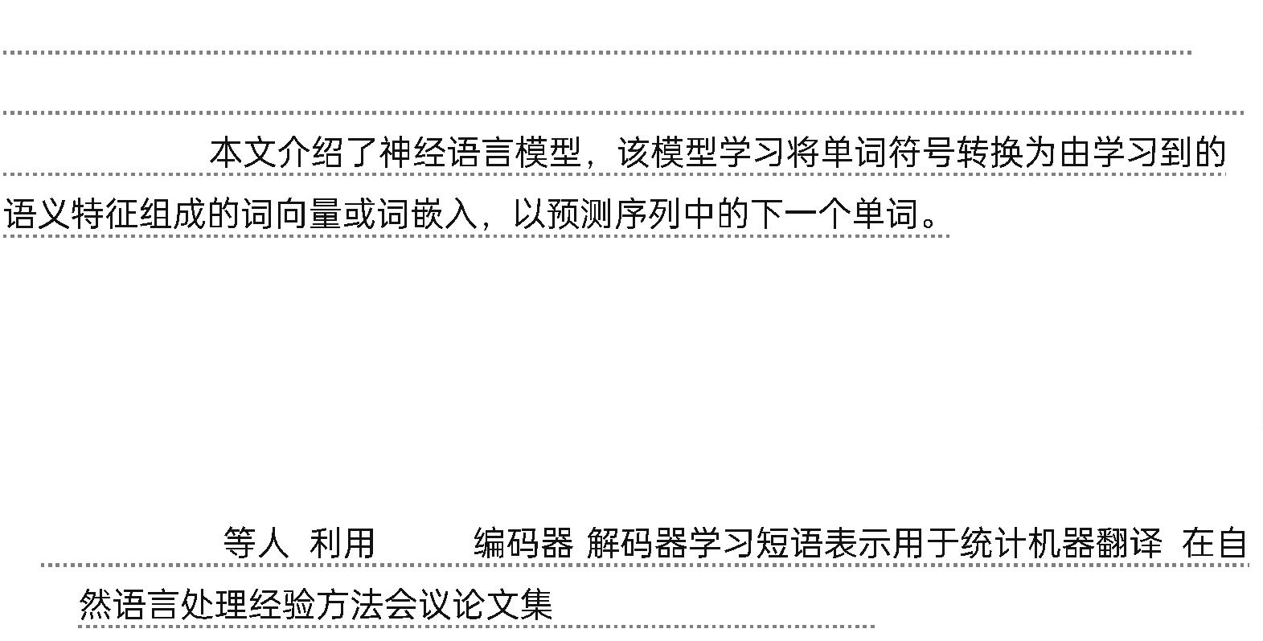

73. Schwenk, H. Continuous space language models.Computer Speech
Lang.21, 492–518 (2007).
74. Socher, R., Lin, C. C-Y., Manning, C. & Ng, A. Y. Parsing natural
scenes and natural language with recursive neural networks.In
Proc.International Conference on Machine Learning 129–136 (2011).
75. Mikolov, T., Sutskever, I., Chen, K., Corrado, G. & Dean, J.
Distributed representations of words and phrases and their
compositionality. In Proc. Advances in Neural Information Processing
Systems 26 3111–3119 (2013).
76. Bahdanau, D., Cho, K. & Bengio, Y. Neural machine translation by
jointly learning to align and translate.In Proc.International Conference on
Learning Representations http://arxiv.org/abs/1409.0473(2015).
77. Hochreiter, S. Untersuchungen zu dynamischen neuronalen Netzen
[in German] Diploma thesis, T.U. Münich (1991).
78. Bengio, Y., Simard, P. & Frasconi, P. Learning long-term
dependencies with gradient descent is difﬁcult.IEEE Trans.Neural
Networks 5, 157–166 (1994).
79. Hochreiter, S. & Schmidhuber, J. Long short-term memory. Neural
Comput.9, 1735–1780 (1997).
This paper introduced LSTM recurrent networks, which have become
a crucial ingredient in recent advances with recurrent networks
because they are good at learning long-range dependencies.
LSTM
80. ElHihi, S. & Bengio, Y. Hierarchical recurrent neural networks for
long-term dependencies.In Proc. Advances in Neural Information


Processing Systems 8 http://papers.nips.cc/paper/1102-hierarchical-re
current-neural-networks-forlong-term-dependencies (1995).
81. Sutskever, I. Training Recurrent Neural Networks. PhD thesis, Univ.
Toronto (2012).
82. Pascanu, R., Mikolov, T. & Bengio, Y. On the difﬁculty of training
recurrent neural networks.In Proc.30th International Conference on
Machine Learning 1310– 1318 (2013).
83. Sutskever, I., Martens, J. & Hinton, G. E. Generating text with
recurrent neural networks.In Proc.28th International Conference on
Machine Learning 1017– 1024 (2011).
84. Lakoff, G. & Johnson, M. Metaphors We Live By (Univ. Chicago
Press, 2008).
85. Rogers, T. T. & McClelland, J. L. Semantic Cognition: A Parallel
Distributed Processing Approach (MIT Press, 2004).
86. Xu, K. et al. Show, attend and tell: Neural image caption generation
with visual attention.In Proc.International Conference on Learning
Representations http:// arxiv.org/abs/1502.03044(2015).
87. Graves, A., Mohamed, A.-R.& Hinton, G. Speech recognition with
deep recurrent neural networks.In Proc.International Conference on
Acoustics, Speech and Signal Processing 6645–6649 (2013).
88. Graves, A., Wayne, G. & Danihelka, I. Neural Turing machines.htt
p://arxiv.org/ abs/1410.5401(2014).
89. Weston, J. Chopra, S. & Bordes, A. Memory networks.http://arxiv.or
g/ abs/1410.3916(2014).
90. Weston, J., Bordes, A., Chopra, S. & Mikolov, T. Towards AI-
complete question answering: a set of prerequisite toy tasks.http://arxi

v.org/abs/1502.05698 (2015).
1. Hinton, G. E., Dayan, P., Frey, B. J. & Neal, R. M. The wake-sleep
9
algorithm for unsupervised neural networks.Science 268, 1558–1161
(1995).
92. Salakhutdinov, R. & Hinton, G. Deep Boltzmann machines.In Proc.
International Conference on Artificial Intelligence and Statistics 448–455
(2009).
93. Vincent, P., Larochelle, H., Bengio, Y. & Manzagol, P.-A. Extracting
and composing robust features with denoising autoencoders.In
Proc.25th International Conference on Machine Learning 1096–1103
(2008).
94. Kavukcuoglu, K. et al. Learning convolutional feature hierarchies for
visual recognition.In Proc. Advances in Neural Information Processing
Systems 23 1090–1098 (2010).
95. Gregor, K. & LeCun, Y. Learning fast approximations of sparse
coding.In Proc. International Conference on Machine Learning 399–406
(2010).
96. Ranzato, M., Mnih, V., Susskind, J. M. & Hinton, G. E. Modeling
natural images using gated MRFs.IEEE Trans.Pattern Anal.Machine
Intell.35, 2206–2222 (2013).
97. Bengio, Y., Thibodeau-Laufer, E., Alain, G. & Yosinski, J. Deep
generative stochastic networks trainable by backprop. In Proc.31st
International Conference on Machine Learning 226–234 (2014).
98. Kingma, D., Rezende, D., Mohamed, S. & Welling, M. Semi-
supervised learning with deep generative models.In Proc. Advances in
Neural Information Processing Systems 27 3581–3589 (2014).

99. Ba, J., Mnih, V. & Kavukcuoglu, K. Multiple object recognition with
visual attention.In Proc.International Conference on Learning
Representations http:// arxiv.org/abs/1412.7755(2014).
100.Mnih, V. et al. Human-level control through deep reinforcement
learning.Nature 518, 529–533 (2015).
101.Bottou, L. From machine learning to machine
reasoning.Mach.Learn.94, 133–149 (2014).
102.Vinyals, O., Toshev, A., Bengio, S. & Erhan, D. Show and tell: a
neural image caption generator. In Proc.International Conference on
Machine Learning http:// arxiv.org/abs/1502.03044(2014).
103.van der Maaten, L. & Hinton, G. E. Visualizing data using t-SNE.J.
Mach.Learn. Research 9, 2579–2605 (2008).

